**Abstract**

Mood is a mental state that is induced by complicated causes. It affects how we behave and make decisions. It is an important social signal that others leverage to better interact with us. If our application knows user mood, it will not only allow more personalized, situated services but also facilitate our social interaction.

Our applications balance your mood and make it suitable and joyful, and then we made up our application name from the word joyful mood (MOOJOY). MOOJOY will retrieve quotes and recommended favorite songs with the ability to share it with friends.

**Acknowledgment**

It is a humbling experience to acknowledge those people who have, mostly out of kindness, helped along the graduation project process. we are indebted to so many for encouragement and support.

Our sincerest thanks are extended to our project supervisor and mentored Khalid Fathy, for his encouragement and guidance. We direct Another special thank for Eng Ahmed Hosney he did a lot and pushed us through the whole process.

Several people helped with: the collection of samples, analyses in the testing and developing phase, the preparation of the App, providing advice and they are all thanked for their contributions. Special mention goes to Eng. Abd Al Rahman Hosny Sub teacher in CS department in Assiut University ,Mahmoud Hamdy Nassar and Ahmed Adel our colleagues friends .

To our many friends and family, you should know that your support and encouragement was worth more than I can express on paper.

Thanks for our Fathers and Mothers you were always there with a word of encouragement or listening ear.

To our friends who cared enough to join us with their opinions and appearance in our testing phase.

Thank you all a lot ...

Contents

Chapter 1 5

Introduction 5

Chapter 2 7

Technical Tools 7

2.1 Java 8

2.2 Eclipse 9

2.3 PHP 9

2.4 XML 10

2.5 Volley 11

2.6 JSON 11

2.7 SoundCloud API 12

2.8 PhpStorm 14

2.9 SublimeText 14

2.10 ngrok 15

2.11 MySQL Workbench 17

Chapter 3 18

Android 18

3.1 What is Android? 19

3.2 Features & Specifications 19

3.3 Applications 20

3.4 Why Android? 20

Chapter 4 22

Emotion Detection 22

4.1 What is Emotion Detection? 23

4.2 Goals of Emotion Detection 23

4.3 Methods of Emotion Detection Technique 24

Chapter 5 38

Recommendation System 38

5.1 Approaches of Recommendation System 39

5.2 Music recommendations 43

5.3 Echo Nest API 46

5.4 Quotes API 55

Chapter 6 57

Text Mining 57

6.1 What is text mining? 58

6.2 Goals of Text Mining 58

6.3 Text mining and text analytics 59

6.4 Typical Applications for Text Mining 59

6.5 Approaches to Text Mining 60

6.6 Text Mining Algorithms 61

Chapter 7 64

Back End 64

7.1 API6 - application programming interface 65

7.2 APIs which we used in our App 69

7.3 Laravel 70

7.4 Services in our App 71

Chapter 8 77

Competitors 77

Chapter 10 83

Experiments results 83

10.1 Snapdragon results 84

10.2 Text mining results 96

10.3 Quotes API results 107

Refrences 107

# Chapter 1

# Introduction



We live in smartphones society. Smartphones has infiltrated the most fundamental aspects of our lives like social organizations and communication connections.

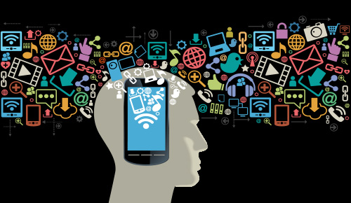 Smartphones are revolutionary and indeed make things easier for us. We can take a picture and send it to someone across the world and communicate with all people over the world.

After we say effects of smartphones in our lives. We decided to make a something, which can interact with user and help him in change his mood if he suffering from negative and bad feelings.

Our motivation is making an Android mobile application that detects the person's mood and interacts with the others through his favorites (songs and quotes).

Also user can follow/un-follow friends, share his mood with his friends, select his favorite samples of songs and retrieves similar songs from Soundcloud and quotes that help the user to make him better or more positive.

So we implement MOOJOY



# Chapter 2

# Technical Tools



## 2.1 Java



**2.1.1 What is Java?**

Java is a general-purpose computer programming language that is concurrent, class-based, object-oriented and specifically designed to have as few implementation dependencies. First released by Sun Microsystems in 1995.

**2.1.2 Why use Java**

* It is intended to let application developers write once, run anywhere (WORA), meaning that the compiled Java code run on all platforms that support java without the need for recompilations.
* Java applications are typically compiled to bytecode that run on any java virtual machine (JVM).
* Java is the one of the most programming languages in use particularly for Client and Server web applications.
* Java allows you to play online games, chat with people around the world.
* It includes automatic storage management, typically using a garbage collector, to avoid the safety problems of explicit deallocation. High-performance garbage-collected implementations can have bounded pauses to support systems programming and real-time applications.
* Java technology allows you to work and play in a secure computing environment.
* Java is fast, secure, and reliable.
* Sun released most of its Java source code as free software in May 2007, so it can now almost be considered a free Java implementation.
* Java implementations include compilers, runtimes, class libraries, etc.

## 2.2 Eclipse

**2.2.1 What is Eclipse?**

Eclipse is an integrated development environment (IDE) Eclipse can be used to develop android applications.Eclipse also used to develop application in other programming languages: PHP, JavaScript, Haskell, C, C++, Ruby, and Ada. It can also be used to develop packages for the software Mathematics. The Eclipse software development kit (SDK) which includes the Java development tools, is meant for Java developers.

**2.2.2 Why use Eclipse**

Android Development Tools (ADT) is a plugin for the Eclipse IDE that extends the capabilities of Eclipse to let you quickly set up new Android projects, create an application UI, add packages based on the Android Framework API, debug your applications using the Android SDK tools, and even export signed (or unsigned) .apk files in order to distribute your application.

## 2.3 PHP

**2.3.1 Definition of PHP?**

PHPis a server side scripting language that is embedded in HTML and that is especially suited in web Development. It is used to manage dynamic content, database, session tracking, even build entire e-commerce sites. It is integrated with a number of popular database including MySQL, Oracle and Microsoft SQL Server.

**2.3.2 Why we use PHP?**

* The simplicity, Familiarity and security are most characteristic that make us use PHP.

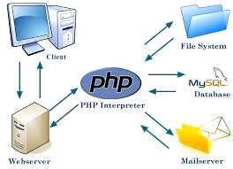

Figure 2.1 PHP Hosting with MySQL

* PHP is a widely-used, free, and efficient alternative to competitors such as Microsoft's ASP.

## 2.4 XML

**2.4.1 What is XML?**

Extensible Markup Language (XML) is amarkup language that defines a set of rules for encoding documents in format which is both human readable and machine readable.

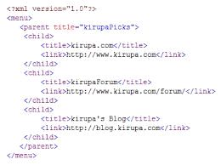

Figure 2.2 Example of XML code

**2.4.2 Why we use XML**

Extensible Markup Language (XML) is

* Simple.
* Very flexible text format derived from SGML.
* Originally designed to meet the challenges of large-scale electronic publishing.
* XML is also playing an increasingly important role in the exchange of a wide variety of data on the Web and elsewhere.

**2.4.3 Application of XML**

* XML has also been employed as the base language forcommunication protocol. Such as XMPP.
* XMLalso used in applications for Microsoft .Net Framework for configurations.
* XML has come into common use for the interchange of data over the Internet.
* XML-based formats have become the default for many office-productivity tools including Microsoft Office.
* Apple has an implementation of a registry based on XML.

## 2.5 Volley

**2.5.1 What is Volley?**

Volley is an HTTP library that makes networking for Android apps easier and most importantly, faster.

**2.5.2 Why Volley**

* Automatic scheduling of network requests**.**
* Multiple concurrent network connections.
* Debugging and tracing tools.
* Support for request prioritization.
* Strong ordering that makes it easy to correctly populate your UI with data fetched asynchronously from the network.

## 2.6 JSON

**2.6.1 What is JSON?**

JSON (JavaScript Object Notation) is a lightweight data interchange format. It is for human to read and write. It is easy for machines to parse and generate. It based on subset of JavaScript Programming Language.JSON is a text format that is completely language independent.

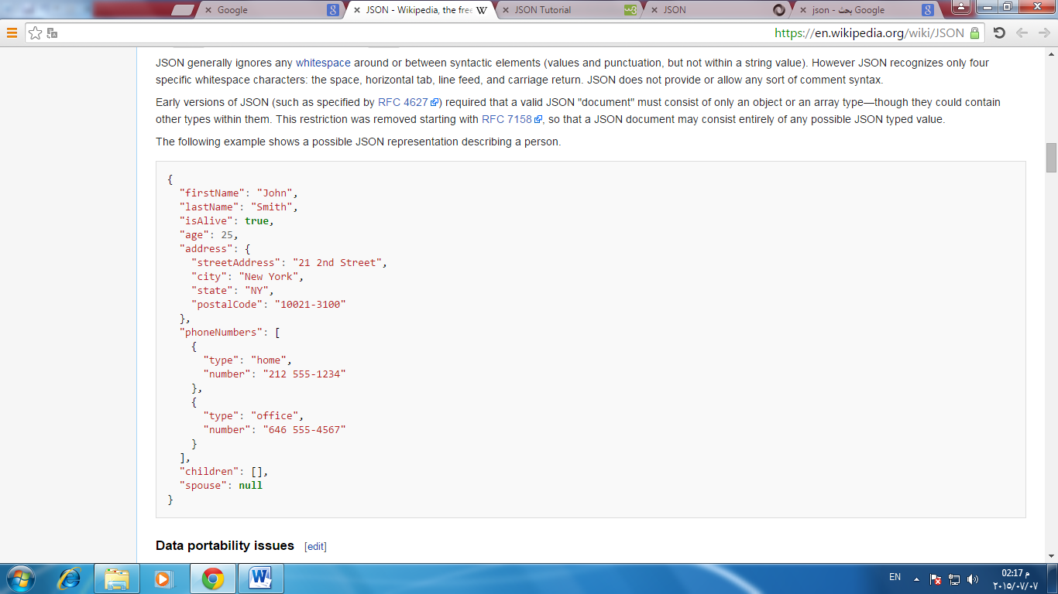

Figure 2.3 JSON format

**2.6.2 JSON features**

* Code for parsing and generating JSON data is readily available in many programming language.
* JSON is an easier-to-use alternative to XML.

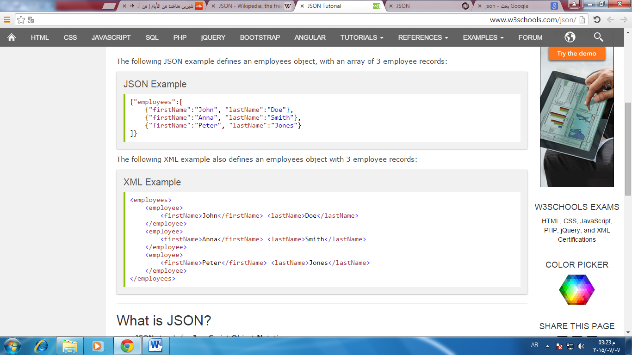

Figure 2.4 JSON format VS XML format.

## 2.7 SoundCloud API

**2.7.1 HTTP API Reference**

SoundCloud API exposes Sound Cloud resources like sounds, sets and users. These resources can be accessed and manipulated using the HTTP methods GET, POST, PUT and DELETE.

## In our application just we need to use Search.

**2.7.2 Search**

* 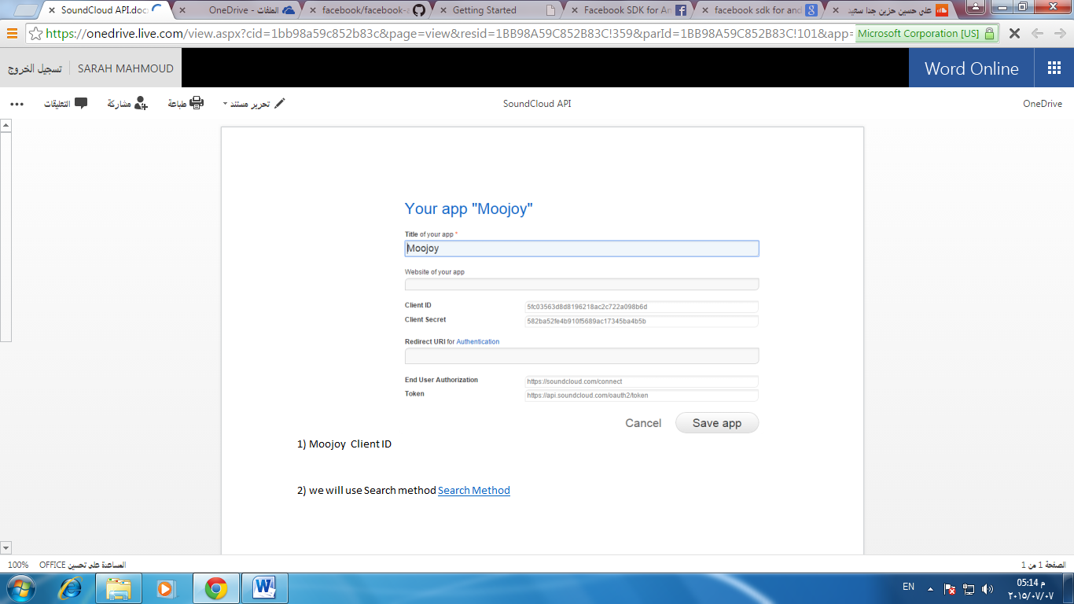At the beginning, we registered MOOJOY.

Figure 2.5 MOOJOY registration.

* Resources such as sounds, users, sets and groups can be searched using Sound Cloud API. Most endpoints will accept a q param which you can use to specify a keyword to search for in fields like title ,username ,description etc. depending on the resource type.

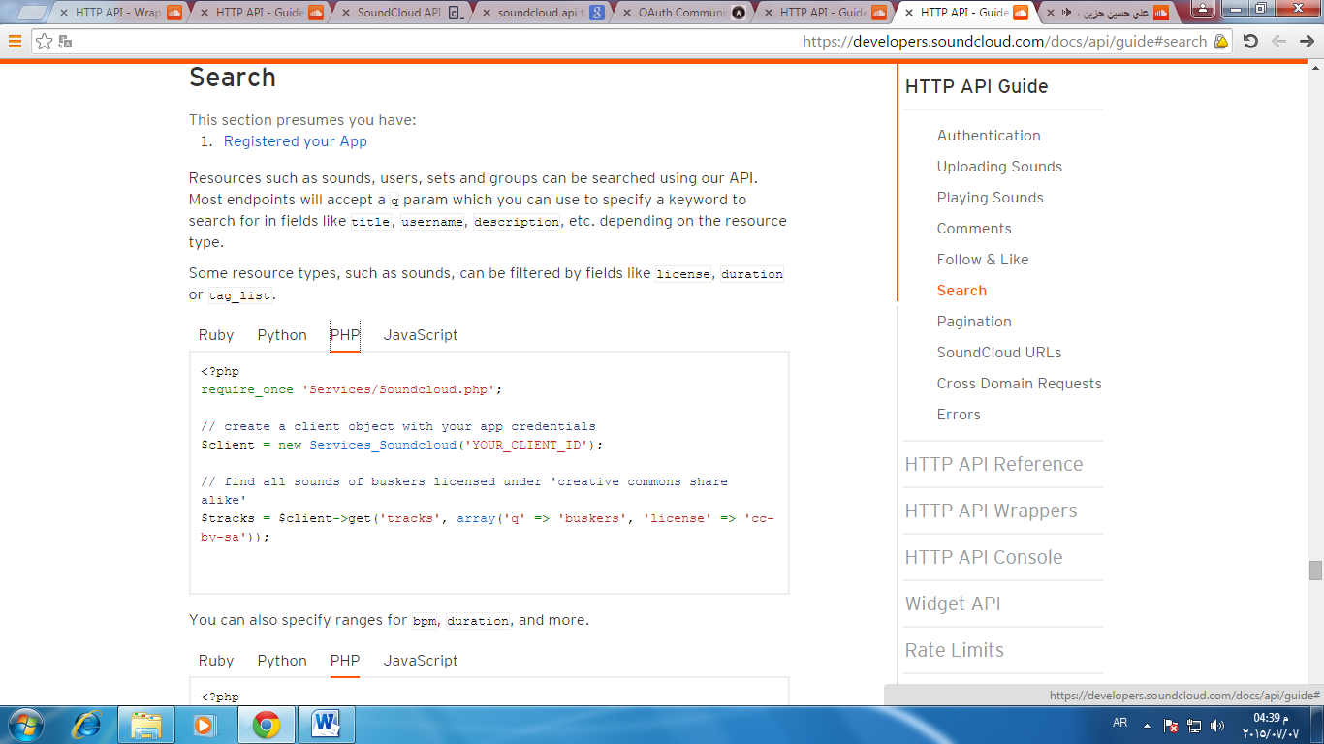

Figure 2.6 Search method.

## 2.8 PhpStorm

**2.8.1 What is PhpStorm?**

PhpStorm provides an editor forPHP, HTML and JavaScript with code analysis and error prevention. PhpStorm is built on IntelliJIDEA, which is written in Java.

**2.8.2 Why PhpStorm**

* Smart PHP Code Editor.
* Code Quality Analysis.
* Fast and Safe Refactoring.
* Easy Debugging and Testing.
* Frameworks Support.
* HTML/CSS/JavaScript Editor.
* Easy Code Navigation and Search.

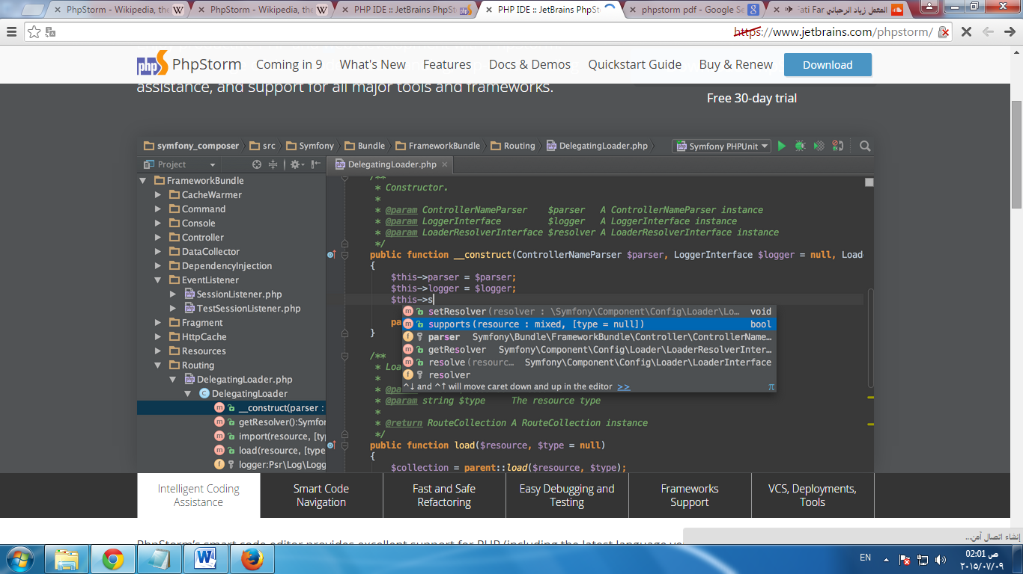

Figure 2.7 PhpStorm.

## 2.9 SublimeText

**2.9.1 What is Sublime Text?**

Sublime Text is a cross platform text and source code editor with a Python Application Programming Interface (API). It supports many programming languages and markup languages.

**2.9.2 Sublime Text Features**

* Use Goto Anything to open files with only a few keystrokes, and instantly jump to symbols, lines or words.
* Sublime Text is available for OS X, Windows and Linux.
* Sublime Text has a powerful, Python based plugin API. Along with the API, it comes with a built in Python console to interactively experiment in real time.

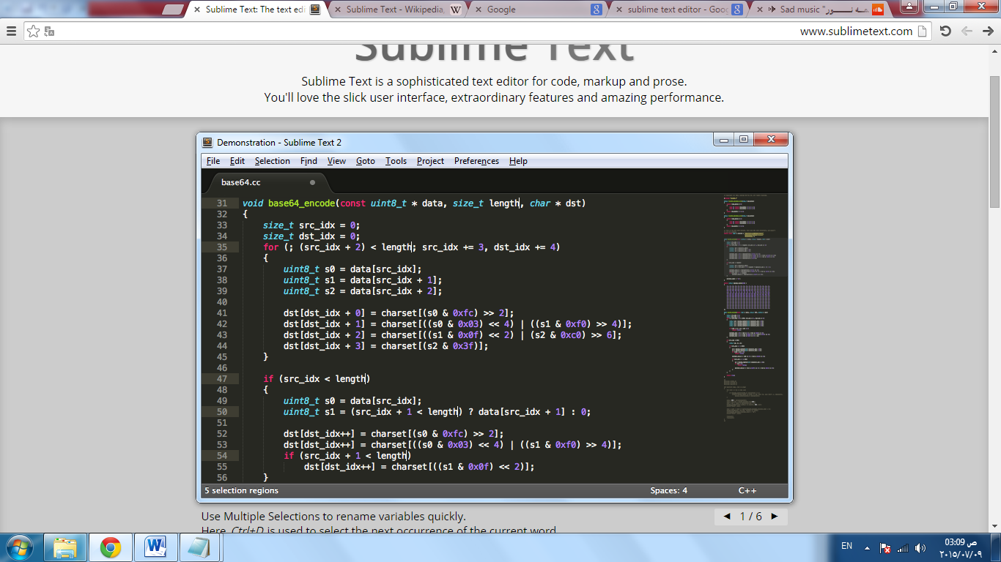

Figure 2.8 Sublime Text

## 2.10 ngrok

**2.10.1 What is ngrok**?

ngrok allows you to expose a web server running on your local machine to the internet. Just tell ngrok what port your web server is listening on.

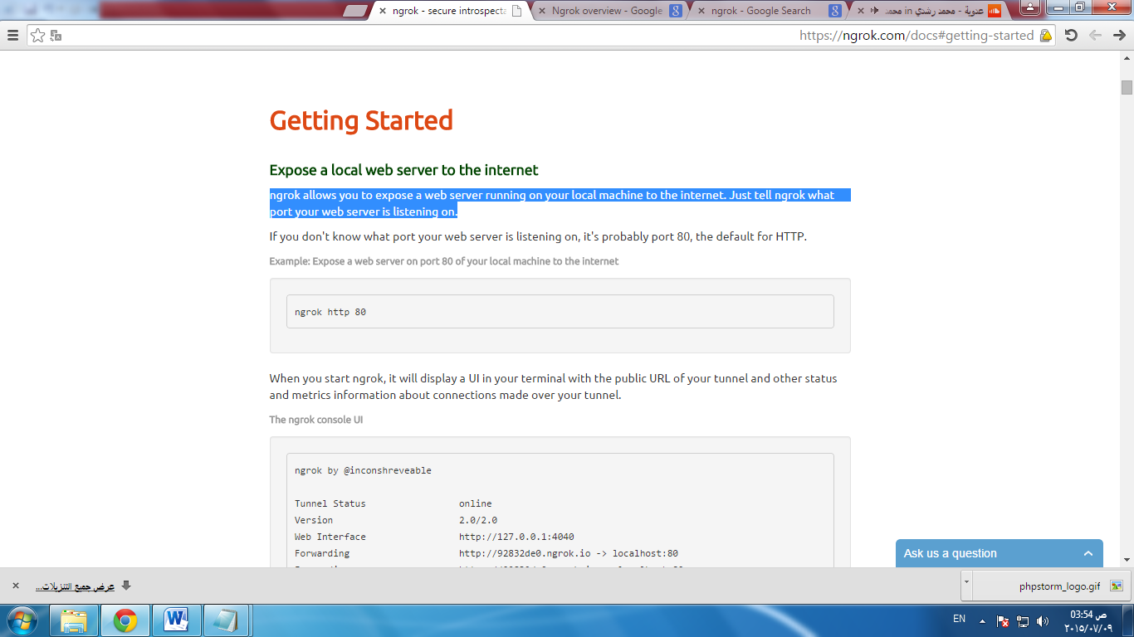

Figure 2.10 ngrok default port.

ngrok provides a real-time web UI where you can introspect all of the HTTP traffic running over your tunnels.

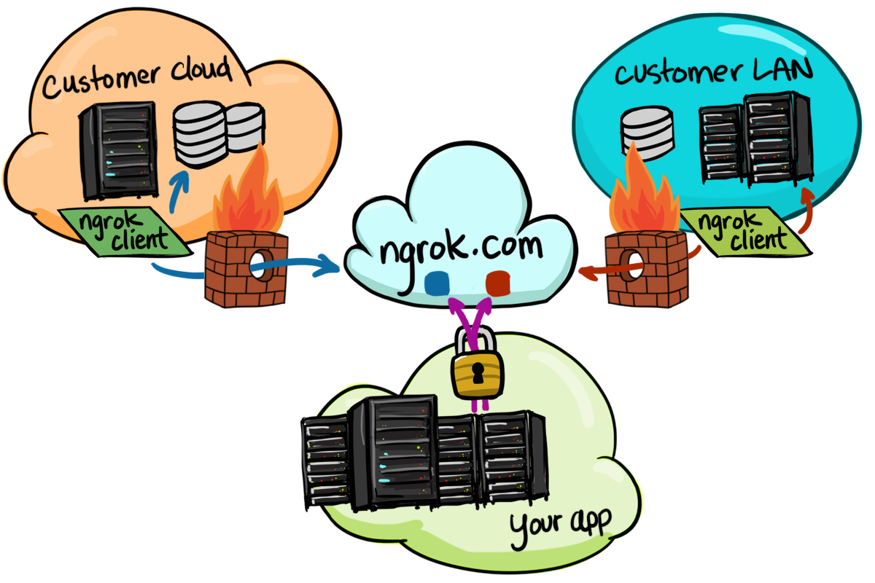

Figure 2.11 ngrok

## 2.11 MySQL Workbench

**2.11.1 What is MySQL Workbench**

MySQL Workbench is a unified visual tool for database architects, developers, and DBAs. MySQL Workbench provides data modeling, SQL development, and comprehensive administration tools for server configuration, user administration, backup, and much more. MySQL Workbench is available on Windows, Linux and Mac OS X.

**2.11.2 MySQL Workbench Features**

* MySQL Workbench enables a DBA, developer, or data architect to visually design, model, generate, and manage databases**.**
* MySQL Workbench delivers visual tools for creating, executing, and optimizing SQL queries.
* MySQL Workbench provides a visual console to easily administer MySQL environments and gain better visibility into databases. Developers and DBAs can use the visual tools for configuring servers, administering users, performing backup and recovery, inspecting audit data, and viewing database health.
* MySQL Workbench provides a suite of tools to improve the performance of MySQL applications.
* MySQL Workbench now provides a complete, easy to use solution for migrating Microsoft SQL Server, Microsoft Access, Sybase ASE, PostreSQL, and other RDBMS tables, objects and data to MySQL.

# Chapter 3

# Android



## 3.1 What is Android?

Android is an open source and Linux-based operating system for mobile devices such as smartphones and tablet computers. Android was developed by the Open Handset Alliance, led by Google, and other companies.

The Open Handset Alliance (OHA) is a consortium of 84 firms to develop open standards for mobile devices. Member firms include Google, HTC, Sony, Dell, Intel, Motorola, Qualcomm, Texas Instruments, Samsung Electronics, LG Electronics, T-Mobile, Sprint Corporation, and Wind River Systems.

## ****3.2 Features &**** Specifications

Android is a powerful Operating System supporting a large number of applications in [Smart Phones](http://www.engineersgarage.com/articles/smart-phones). These applications make life more comfortable and advanced for the users. Hardwares that support Android are mainly based on [ARM architecture](http://www.engineersgarage.com/articles/arm-advanced-risc-machines-processors) platform. Some of the current features and specifications of android are:

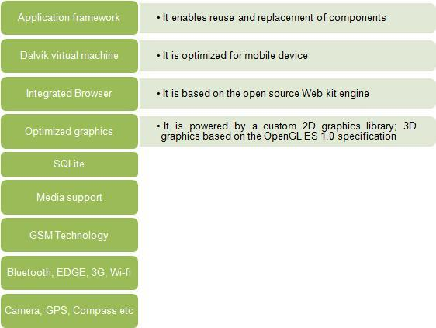

Figure 3.1 Android framework

Android applications are written in java programming language. Android is available as open source for developers to develop applications which can be further used for selling in android market. Android relies on Linux version 2.6 for core system services such as security, memory management, process management, network stack, and driver model. For software development, Android provides **Android SDK** (Software development kit).

## ****3.3**** Applications

These are the basics of Android applications:

* Android applications are composed of one or more application components (activities, services, content providers, and broadcast receivers).
* Each component performs a different role in the overall application behavior, and each one can be activated individually (even by other applications).
* The manifest file must declare all components in the application and should also declare all application requirements, such as the minimum version of Android required and any hardware configurations required.
* Non-code application resources (images, strings, layout files) should include alternatives for different device configurations (such as different strings for different languages).

## 3.4 Why Android?

Android popularity is growing in size. I have an Android phone and I will explain some advantages of using Android instead of some other operating system. There are four reasons in no particular order.

**Reason #1: Widgets**

Android allows you to add little shortcuts to apps on the home screen. Most apps have a corresponding widget, some more helpful than others.

**Reason #2: Many options**

Samsung makes phones, LG makes phones, HTC makes phones, Sony makes phones, Motorola makes phones, and all of these companies make phones running the exact same operating system, Android. When you are looking for an Android device, make sure you look at all the flagships for each respective company.

**Reason #3: Syncs with Google account**

My Google account is my most powerful asset. I keep apps, movies, magazines, emails, YouTube videos, contacts, google+ and maps all in my Google account. The fact that I can simply sign in to my google account and have all of my information restored is remarkably convenient.

If you are a heavy user of Gmail, or any other Google service, Android will definitely suit your needs.

**Reason #4: Socially integrated**

Not only does Android have Facebook integration but Instagram, Google+ and pretty much every other social network you can think of! This integration is very helpful when wanting to transport images to your social profile or to a cloud storage service like Dropbox straight from the preinstalled gallery app.

So, these were my four reasons why you should use Android. Since I have only given positive information regarding Android it may seem as though I am saying that there is nothing wrong with it.

# Chapter 4

# Emotion Detection

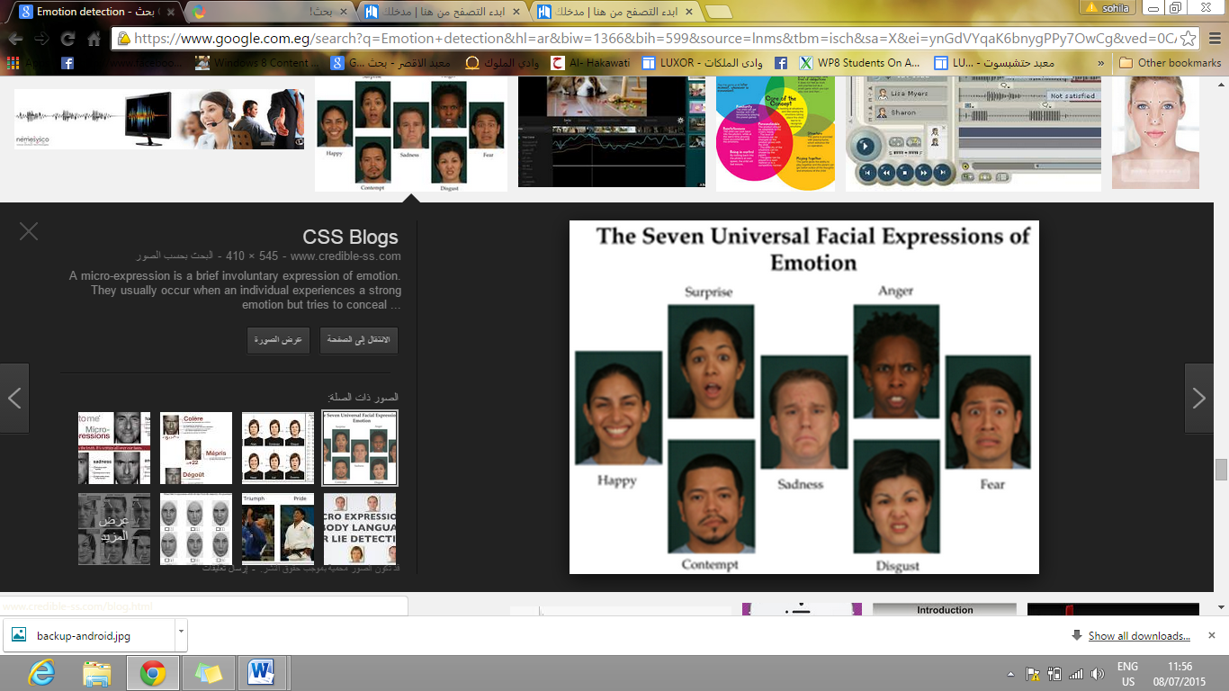

Recently there has been a growing interest in improving the interaction between humans and computers. It is argued that to achieve effective human-computer intelligent interaction, there is a need for the computer to interact naturally with the user, similar to the way humans interact. Humans interact with each other mostly through speech, but also through body gestures to emphasize a certain part of speech and/or display of emotions.One of the most important ways for humans to display emotions is through facial expressions. If we want to achieve more effective human-computer interaction, recognizing the emotional state of the human from his or her face could prove to be an invaluable tool.

This Chapter describes a real-time automatic facial expression recognition system. Our work focuses on initially detecting the human face, on classifying the human emotion from facial features and on visualizing the recognition results.

## 4.1 What is Emotion Detection?

The detection of emotions is based on the calculation of distances between various feature points. In this step comparison between distances of testing image and neutral image is done and also it selects the best possible match of testing image. It also classifies the emotions on the basis other distances calculated. And the final results are displayed.



Figure 4.1 Points movements of Face

## 4.2 Goals of Emotion Detection

**First goal**: Investigating variables that predicted emotion detection skills among men.

**Second goal:** Examining variables that predicted behaviors among men, including emotional skills and variables.

**Third goal**: interacting with the others through his favorites (songs and quotes).

## 

## 4.3 Methods of Emotion Detection Technique

**4.3.1 Snapdragon SDK for Android**

The Snapdragon SDK for Android is designed to make it easy to integrate facial processing features into your application.

The Snapdragon SDK makes it possible to detect a smile, determine where the eyes are looking, and detect blinking. Using this, you can create new interactions and enhance the user experience by doing things like integrating with real-time camera preview or analyzing photos in a photo album.  
You can track a variety of facial properties with each frame:

* **Blink Detection** – measure how open each eye is
* **Gaze Tracking** – assess where the subject is looking
* **Smile Value** – estimate the degree of the smile
* **Face Orientation** – track the Yaw, Pitch and Roll of the head
* **Facial Expressions**

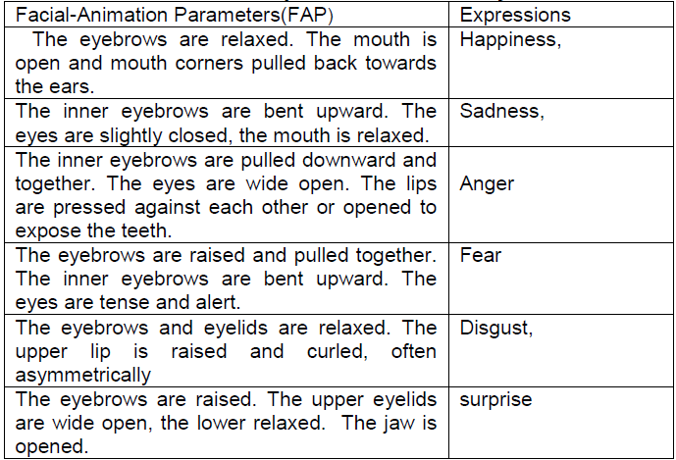

Table 4.1 Emotion detection

-The next numbers are explained in figure 4.8

-Get pitch, yaw and roll are explained in figure 4.9

* **Happiness**

Figure 4.2

1. Mouth(x);
2. Mouth(y);
3. Left eye brow (bottom)(x, y)
4. Left eye brow(top)(x, y)
5. Right eye brow(bottom)(x, y)
6. Right eye brow (top)(x, y)
7. Left eye brow(right)(x, y)
8. Left eye brow(left)(x, y)
9. Right eye brow(right)(x, y)

10-Right eye brow (left) (x, y)

* **Sadness**



Figure 4.3

1. Get pitch (head down).
2. lower corner lip (mouth(x), mouth(y))
3. left eye brow (bottom)
4. left eye brow(top)
5. right eye brow (bottom)
6. right eye brow (top)
7. right eye (x)
8. right eye(y)
9. left eye(x)
10. left eye(y)

* **Disgust**



Figure 4.4

1. Mouth(x)
2. Mouth(y)
3. Left eye (x)
4. Left eye(y)
5. Right eye(x)
6. Right eye(y)
7. Get yaw(head turned away)
8. Nose (bridge(x), bridge(y))
9. Nose(center(x), center (y))

10-Nose (lower left(x), lower right(y))

11-Nose (upper left(x), upper right(y))

12-Nose (middle left(x), middle right(y))

13-Nose tip(x, y)

14-Chin (center)

15-Chin (left)

16-Chin (right)

* **Surprise**

Figure 4.5

1. Left eye (x)
2. Right eye(y)
3. Left eye brow (bottom)(x, y)&&(top)(x, y)
4. Left eye brow(right)(x, y)&&left(x, y)
5. Right eye brow(top)(x, y)&&(bottom)(x, y)
6. Right eye brow (left)(x, y)&&(right)(x, y)
7. Mouth(x)
8. Mouth(y)
9. Chin(center)
10. Chin (left)
11. Chin (right)
12. Get yaw ()
13. Get pitch ()
14. Left eye (y)
15. Right eye(x)

* **Anger**

Figure 4.6

1. Left eye (x)
2. Left eye(y)
3. Right eye(x)
4. Right eye(y)
5. Left eye brow (bottom)(x, y)
6. Left eye brow(top)(x, y)
7. Left eye brow(left)(x, y)
8. left eye brow(right)(x, y)
9. right eye brow(bottom(x, y)) && (top(x, y))
10. right eye brow (left (x, y)) && (right(x, y))
11. chin (center)
12. chin (left)
13. chin (right)
14. mouth (x)
15. mouth(y)

* **Fear**

Figure 4.7

1. Left eye(x)
2. Left eye(y)
3. Right eye (x)
4. Right eye(y)
5. Get eye gaze point()
6. Get eye horizontal gaze point ()
7. Get eye vertical gaze point()
8. Left eye brow(bottom(x, y)) && (top(x, y))
9. Right eye brow(top(x, y)) && (bottom(x, y))

10-Left eye brow (left(x, y)) && (right(x, y))

11-Right eye brow (left(x, y)) && (right(x, y))

12-Mouth(x), mouth(y)

13-Chin (center, left, right)

14-Get pitch ()

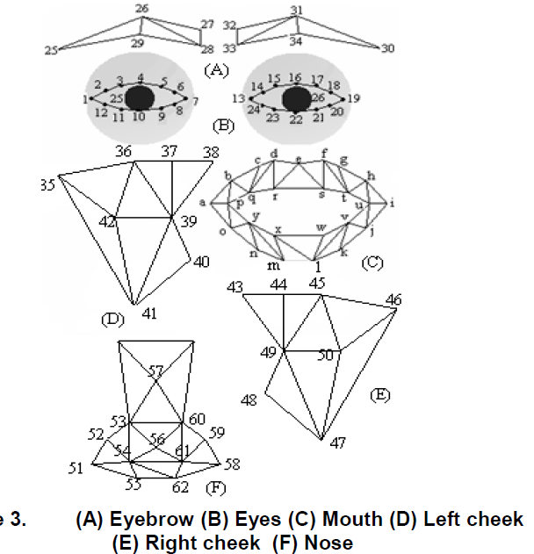

Figure 4.8 A-Eye brows, B-Eye, C-Mouth, D-Left Cheek, E-Right Cheek, and D-Nose

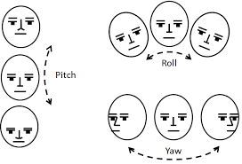

Figure 4.9

**4.3.1.1 Cluster analysis**

Cluster analysis divides data into groups (clusters) that are meaningful, useful, or both. If meaningful groups are the goal, then the cluster should capture the natural structure of the data. There have been many application of cluster analysis to practical problem. Clustering for understanding classes or conceptually meaningful groups of objects that share common characteristics.

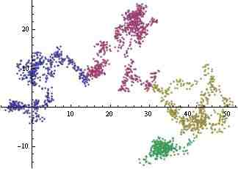

Figure 4.10 Clustering

**What is Cluster analysis?**

Cluster analysis groups of data objects based only on information found in the data that describe the objects and their relationships. The goal is that object within a group be similar (related) to one another and different from (or unrelated to) the objects in other groups.

Fi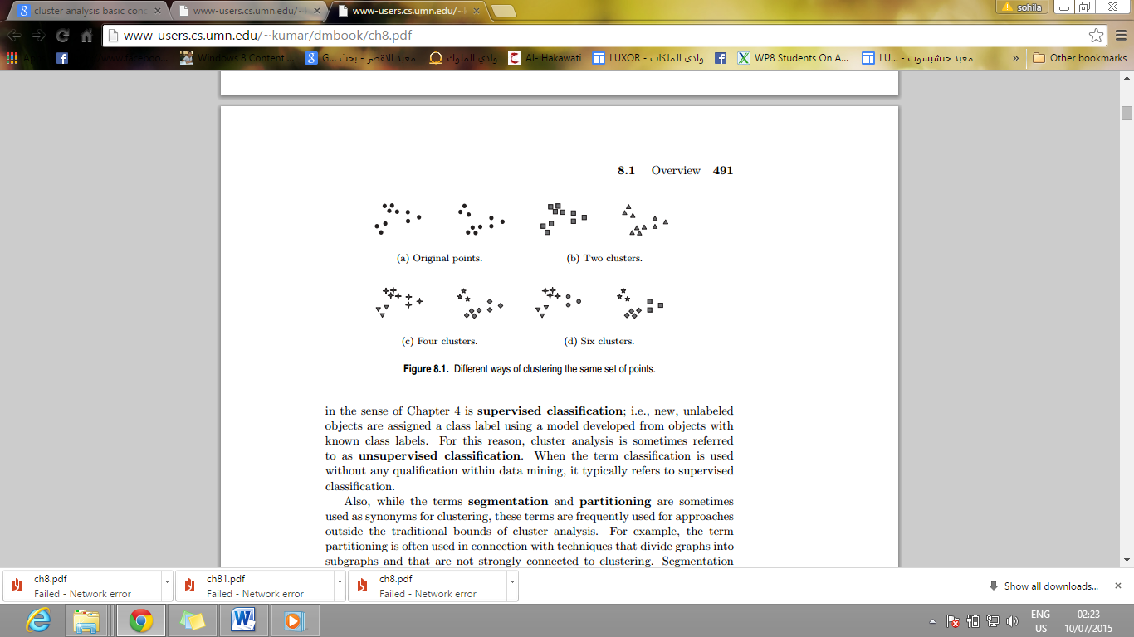gure 4.1 1 Different ways of clustering the same set of points

**Different types of clustering**

* **Hierarchical versus Partitional**

Partitional clustering is simply a division the set of data into

non overlapping subsets (clusters).

Hierarchical clustering which is a sets of nested clusters. That are

organized as a tree.

* **Exclusive versus Overlapping versus Fuzzy**

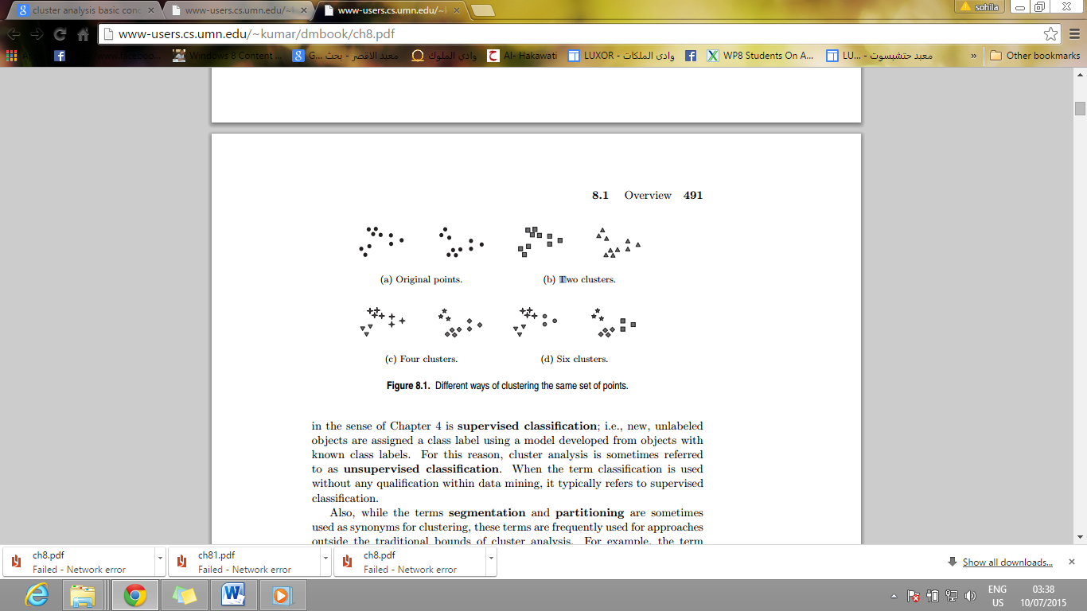 Exclusive clustering assign each object to single cluster.

Figure 4.13 Exclusive clustering

Non-exclusive or Overlapping is used to reflect the fact that

An object can simultaneously belong to the more than one group or class

Fuzzy clustering every object belongs to every cluster with a membership

Weight that is between 0(absolutely does not belong) and

1(absolutely belongs).

* **Complete versus partial**

A complete clustering assigns every object to a cluster whereas a partial cluster dose not.

* **Well -Separate**

A cluster is a set of objects in which each object is closer to every other object in the cluster than to any object not in the cluster.

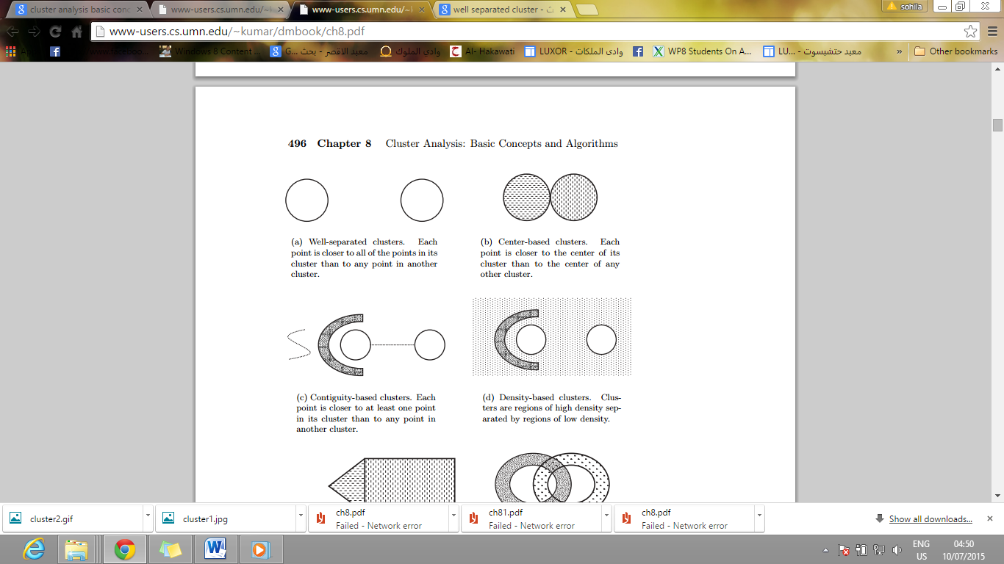

Figure 4.14

* **Prototype- based**

A cluster is a set of objects in which each object is closer to the prototype that defines the cluster than to the prototype of any other cluster. The prototype of any cluster is often centroid.

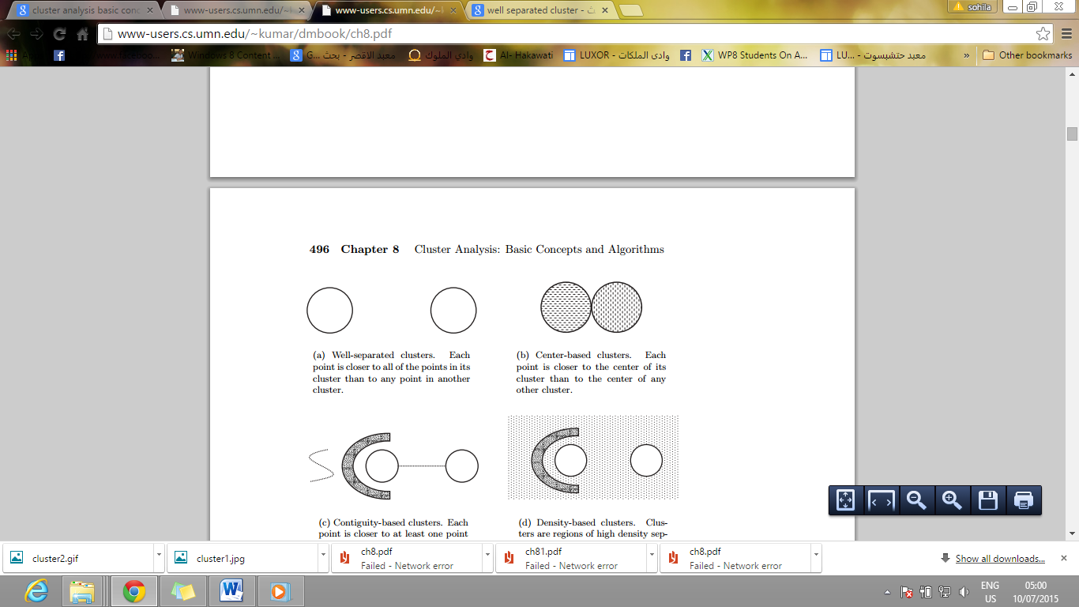

Figure 4.15

* **Graph-Based**

If the data represented as graph where the node are the objects and links represent connections among objects , Then a cluster can be defined as a connected component. A group of objects that are connected to one of another. but that not have connection with objects outside the group. Example of graph based cluster is contiguity –based clusters, where two Objects are connected if they are within specified distance of each other.

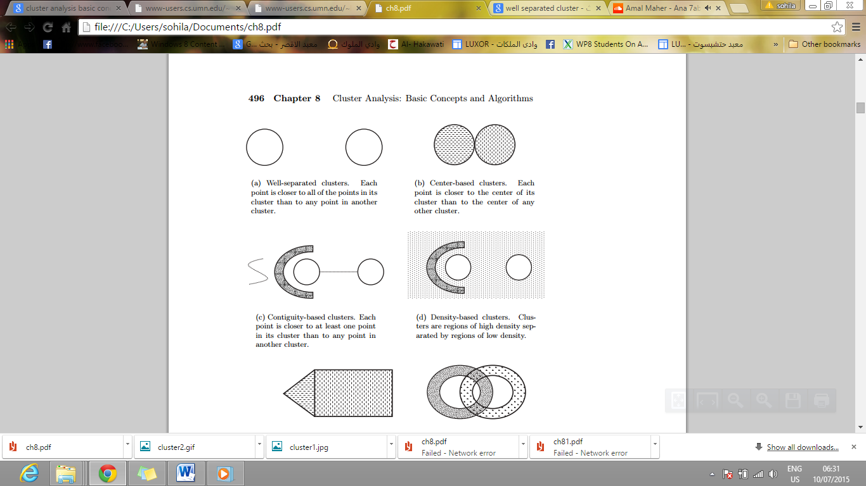

Figure 4.16

* **Density -Based**

A cluster is a dense region of object that are surrounded by a region of low density.

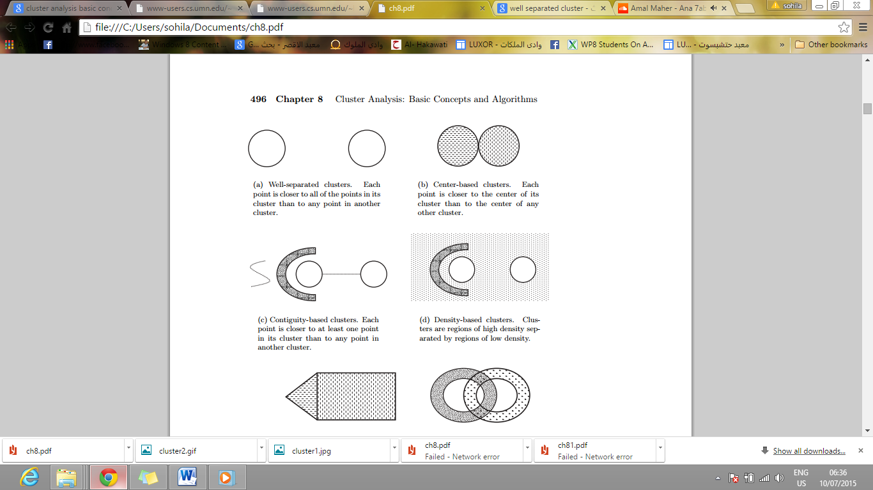

Figure 4.17

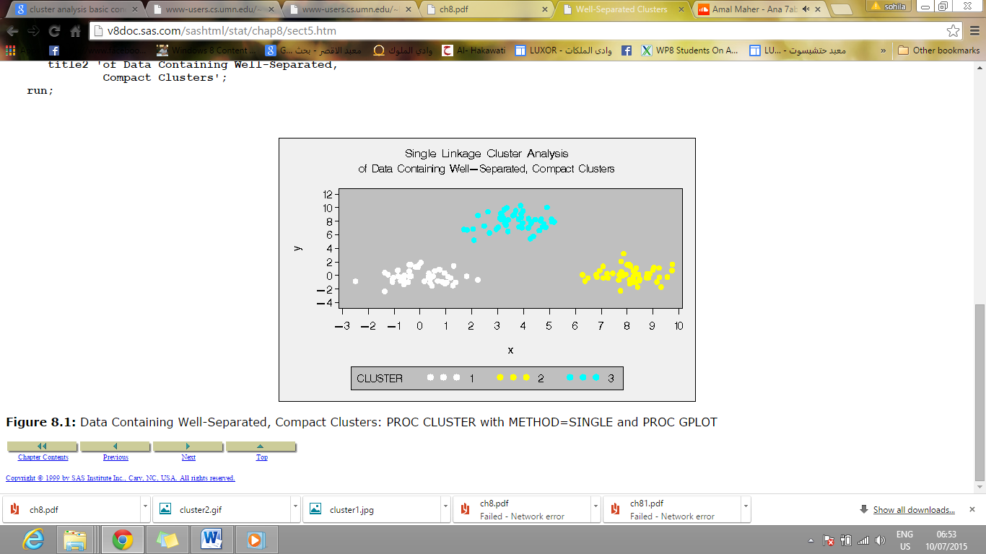

Figure 4.18

**Techniques of cluster analysis**

* K-means
* DBSCAN

**K-means**

Prototype –based clustering techniques, Partitional clustering techniques that attempt to find a user specified number of clusters (K), which are represented by their centroids.

.

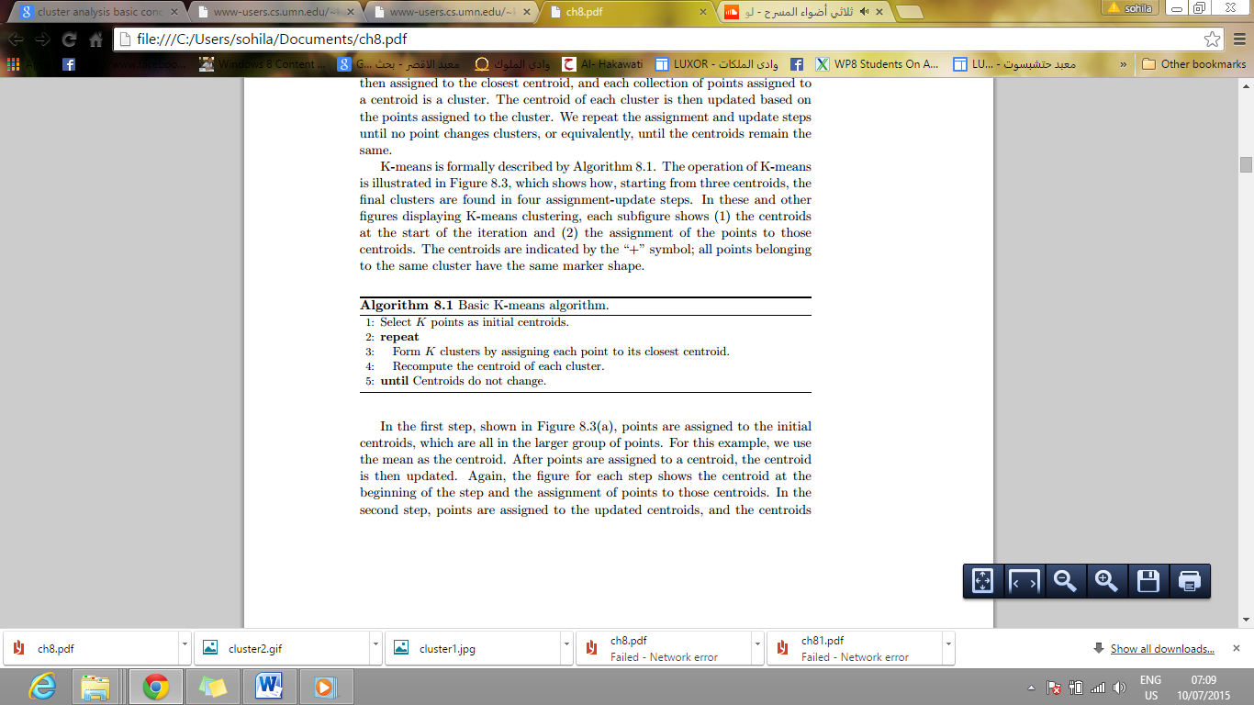

Figure 4.19

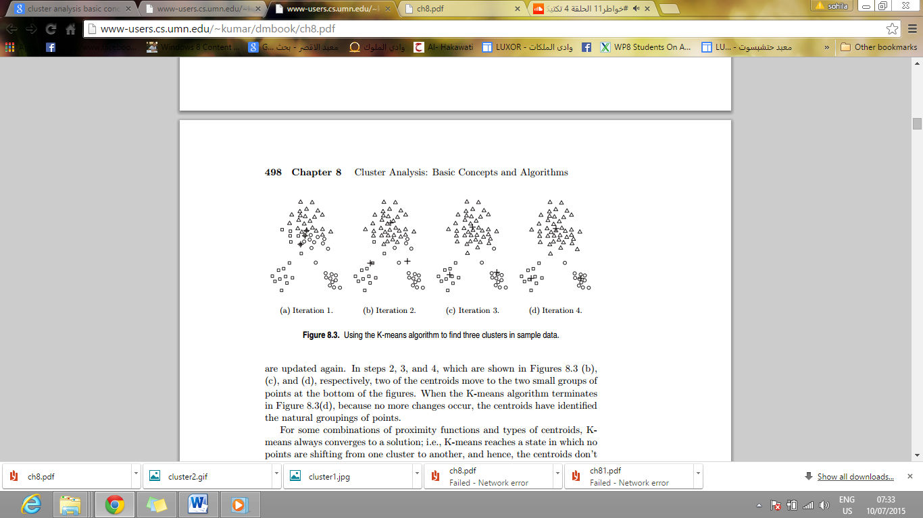

Figure 4.20 Using the k –mean algorithm to find three clusters.

**DBSCAN**

This is a density based clustering algorithm that produce a partitional clustering. Points in low-density regions are classified as noise and omitted. Core point these points are in the interior of a density based cluster.

Border point is not core point but it fall within neighborhood of core point. Noise point is not core points or border points

Any two core points are close enough- within a distance Eps of one another- are put in the same cluster. Any border point that is close enough to core point is put in the same cluster as core point. Noise point is discarded.

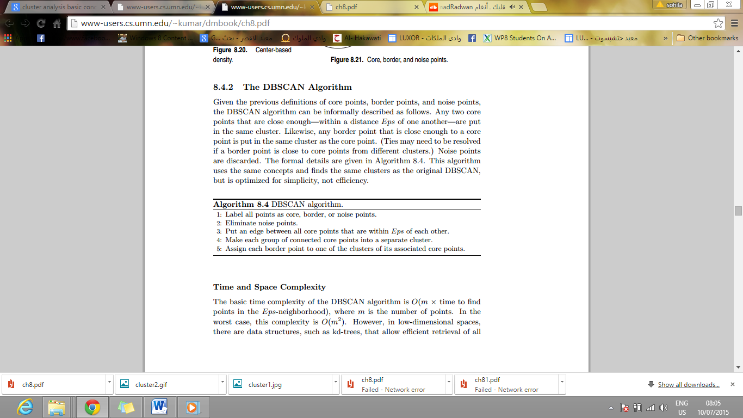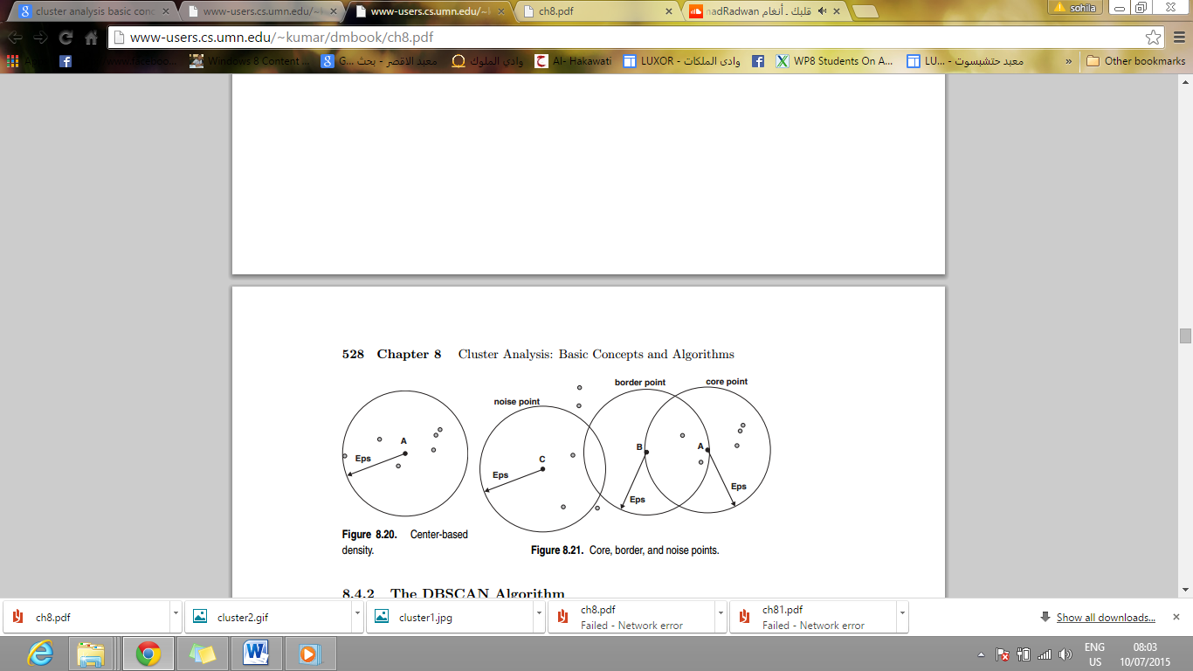

Figure 4.21

Figure 4.22

DBSCAN algorithm interacts with snapdragon SDK by take all values of facial expression and detects mood.

After implementing DBSCAN algorithm, we did not complete because we found the Error percentage is large and found Sky Biometry is more effective.

**4.3.2 Sky Biometry API**

Sky Biometry introduces cloud-based Face Detection and RecognitionAPI. At the core of the product is one of the world’s best algorithms for the detection and recognition of faces that is successfully used in many commercial products around the globe.

Sky Biometry uses completely different computer vision algorithms for face detection and recognition.

**API overview**

This section describes how to use Sky Biometry Face DetectionandRecognition REST API.

API uses **REST** interface. In general, it means that API methods are called over the internet.

Using standard HTTP methodslike GET and POST to[api.skybiometry.com/fc/](http://api.skybiometry.com/fc/). This means that there are no restriction to choosing programming language for development.

Depending on the HTTP request parameters, server can generate response in either JSON or XML.

Common method invocation call looks like this:

http://api.skybiometry.com/fc/{**API method**}. {**Response format}? api_key=...&api_secret=...& {other parameters**}

**API method:** Face Detection and Recognition API method name. Currently supported methods include: faces/detect faces/recognize, faces/train, faces/status, tags/get, tags/add, tags/save, tags/remove, account/authenticate, account/limits and account/users.

**Response format**:json (default) or xml.

API_key and API_secret: these keys are generated automatically when creating application.

**Other parameters:** include common parameters that could be used when calling all methods and method parameters that should be specified when calling only specified method.

Common parameters:

* Callback – JavaScript method to wrap a JSON-formatted response.
* Callback_url – asynchronously invoke specified API method, and POST the response to the specified callback URL.

**Examples**

* http://api.skybiometry.com/fc/faces/detect.json?api_key=aa754b54b37&api_secret=4b3a4c6d4c&urls=http://tinyurl.com/673cksr
* http://api.skybiometry.com/fc/faces/detect.json?api_key=aa754b54b37&api_secret=4b3a4c6d4c&callback=processResponce&urls=http://tinyurl.com/673cksr
* http://api.skybiometry.com/fc/account/limits.xml?api_key=aa754b54b37&api_secret=4b3a4c6d4c
* https://api.skybiometry.com/fc/account/namespaces.xml?api_key=aa754b54b37&api_secret=4b3a4c6d4c

## API authentication

Every call to the API is required to be authorized, which basically means that you must [sign up](https://www.skybiometry.com/Account/Register) and obtain API access keys before accessing the service. Once that is done, you are ready to go coding.

## Sky Biometry provides two ways for the client to authenticate himself:

* API_key and API_secret – by choosing this method every call to API must include API_key and API_secret. By using this fields we can map API call to the API user.
* API_key and domain authentication – there are some situations when disclosing API_secret is not an option (like using java script client code). Instead of disclosing API_secret, API user can choose domain authentication method.

## API usage limits

## Some of the methods of the API (like [faces/detect](https://www.skybiometry.com/Documentation#faces/detect), [faces/group](https://www.skybiometry.com/Documentation#faces/group) and [faces/recognize](https://www.skybiometry.com/Documentation#faces/recognize)) are rate limited. All of the created [application(s)](https://www.skybiometry.com/Account/CreateApplication) share the same limits assigned to current user account. User has the ability to select one of the [subscriptions available](https://www.skybiometry.com/Pricing) which better suits the needs of the application being created. Among available subscriptions is a FREE subscription, which is assigned with a limit of 100 face detection/recognition method calls an hour, monthly usage is limited to 5000 face detection/recognition method calls.

### Supported facial attributes

## Each attribute in *attributes* field in the response have two subfields: value (string) and confidence (integer).

## 

## Table 4.1 Facial attributes.

### If something goes wrong

In case any method of the API fails, then the response object contains status field with a value of "failure" along with error code and error message fields from the following table:

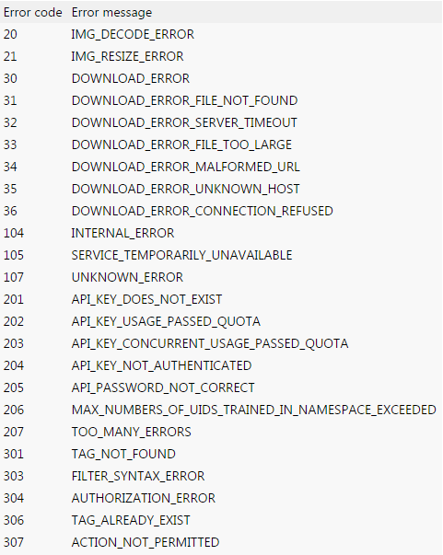

Table 4.2 Errors code and Errors message.

# Chapter 5

# Recommendation System

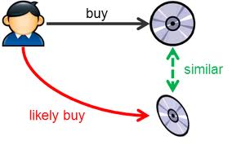

Abstract Recommender System (RSs) are software tools and techniques providing suggestion for items to be of use to a user. The suggestions relate to various decision making processes, such as what item to buy, what item to listen to, or what online news to read.

"Items" is general term used to denote what system recommends to users, in popular web sites, Amazon.com, employs a RS to personalize online stores for each customer. Recommendation Systems are subclass of information filtering system.

Recommender System produces a list of recommendations in two ways

Collaborative filtering.

Content based filtering.

## 5.1 Approaches of Recommendation System

**5.1.1 Collaborative filtering**

One approach to the design of recommender systems that has seen wide use is Collaborative filtering

Collaborative filtering methods are based on collecting and analyzing a large amount of information on users’ behaviors, activities or preferences and predicting what users will like based on their similarity to other users. The underlying assumption of the collaborative filtering approach is that if a person A has the same opinion as a person B on an issue, A is more likely to have B's opinion on a different issue x than to have the opinion on x of a person chosen randomly. For example, a collaborative filtering recommendation system for television tastes could make predictions about which television show a user should like given a partial list of that user's tastes (likes or dislikes).

**Application of Collaborative filtering**

Applications of collaborative filtering typically involve very large data sets. Collaborative filtering methods have been applied to many different kinds of data including: sensing and monitoring data, such as in mineral exploration, environmental sensing over large areas or multiple sensors.

**What CF systems support**

* Recommend item

Amazon.com

* Predict for a given item
* Constrained recommendations
* Recommend from a set of items

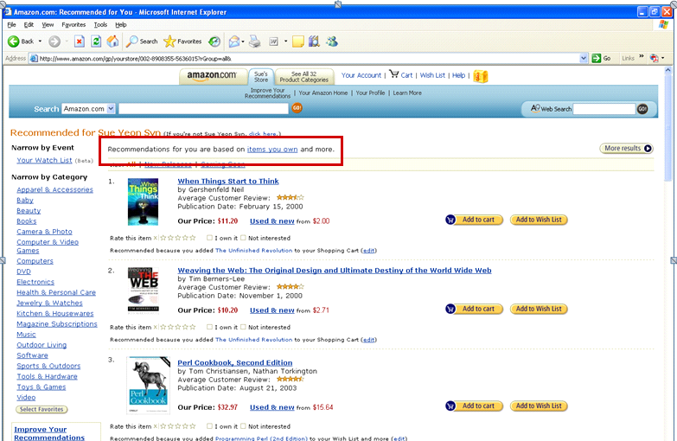

Figure 5.1 Amzon.com

For implements recommender we need to use Mahout. 

**What is Mahout?**

Mahout is a Java library implementing Machine Learning techniques:

•Clustering

•Classification

•Recommendation

Currently Mahout supports mainly four use cases:

* **Recommendation** takes users' behavior and from that tries to find items users might like.
* **Clustering** takes text documents and groups them into groups of topically related documents.
* **Classification** learns from existing categorized documents what documents of a specific category look like and is able to assign unlabeled documents to the (hopefully) correct category.
* **Frequent item set** mining takes a set of item groups (terms in a query session, shopping cart content) and identifies, which individual items usually appear together.

**Recommendation Algorithms**

–User-based Collaborative Filtering

–Item-based Collaborative Filtering

–SlopeOne Recommenders

–Singular Value Decomposition

**Recommendation**

Mahout implements a Collaborative Filtering framework Popularized by Amazon and others, Uses historical data (ratings, clicks, and purchases) to provide recommendations

•**User-based**: Recommend items by finding similar users. This is often harder to scale because of the dynamic nature of users.

•**Item-based**: Calculate similarity between items and make recommendations. Items usually don't change much, so this often can be computed offline.

•**Slope-One**: A very fast and simple item-based recommendation approach applicable when users have given ratings (and not just boolean preferences).

**Recommendation in Mahout**

* **Input:** raw data (user preferences)
* **Output:** preferences estimation

**Step 1** Mapping raw data into a Data Model Mahout-compliant.

**Step 2** Tuning recommender components Similarity measure, neighborhood, etc.

**Recommendation Components**

Mahout implements interfaces to these key abstractions:

–**Data Model**

Methods for mapping raw data to a Mahout-compliant form

–**User Similarity**

Methods to calculate the degree of correlation between two users

–**Item Similarity**

Methods to calculate the degree of correlation between two items

–**User Neighborhood**

Methods to define the concept of ‘neighborhood’

–**Recommender**

Methods to implement the recommendation step itself

A **Data Model** is the interface to draw information about user preferences.

**User Similarity** defines a notion of similarity between two Users.

**Item Similarity** defines a notion of similarity between two Items

**Recommender**

Given a Data Model, a definition of similarity between users (items) and a definition of neighborhood, a recommender produces as output an estimation of relevance for each unseen item

**User Similarity** defines a notion of similarity between two Users.

**Item Similarity** defines a notion of similarity between two Items.

**5.1.2 Content Based filtering**

Another common approach when designing recommender systems is content-based filtering. Content-based filtering methods are based on a description of the item and a profile of the user’s preference.

In a content-based recommender system, keywords are used to describe, In particular, various candidate items are compared with items previously rated by the user and the best-matching items are recommended.

Content-based recommendation systems try to recommend items similar to those a given user has liked in the past. Indeed, the basic process performed by a content-based recommender consists in matching up the attributes of a user profile in which preferences and interests are stored, with the attributes of a content object (item), in order to recommend to the user new interesting items.

This approach has its roots in information retrieval and information filtering research. Information filtering deals with the delivery of items selected from a large collection. That the user is likely to find interesting or useful and can be seen as a classification task.

To abstract the features of the items in the system, an item presentation algorithm is applied. A widely used algorithm is the vector space representation.

To create user profile, the system mostly focuses on two types of information:

1. A model of the user's preference.

2. A history of the user's interaction with the recommender system.

In our application we need music and quotes Recommender System based on Content Based filtering and Collaborative filtering.

## 5.2 Music recommendations

We will go into technologies like collaborative filtering, automatic content based recommendation. When people talk about “music recommendation” or “music discovery” they usually mean one of a few things.

Artist or song similarity: an anonymous list of similar items to your query. You can see this on almost any music service. Without any context, this is just a suggestion of what other artists or songs are similar to the one you are looking at.

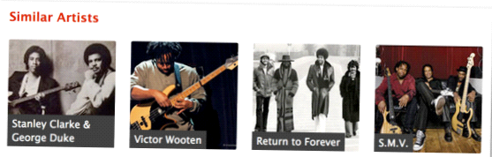

Last.fm recommending music or concerts Figure5.2

**Personalized recommendation**

Given a “user model” (your activity on a service – plays, skips, ratings, purchases) a list of songs or artists that the service does not think you know about yet that fits your profile.

**Playlist generation**

Most consumers of music discovery are using some form of playlist generation. This is different from the above two in that they receive a list of items in some order (usually meant to be listened to at the time.) The playlist can be personalized (from a user model) or not, and it can be within catalog (your own music, ala iTunes Genius’s or Google’s Instant Mix playlists) or not (Pandora, Spotify’s or Rdio’s radio, iHeartRadio.) The playlist should vary artists and types of songs as it progresses, and many rely on some form of steering or feedback (thumbs up, skips).

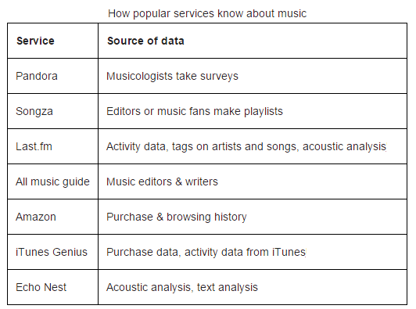Table 5.1

There are many other discovery platforms but this list covers the widest swath of approaches. Many services you interact with use either these platforms directly (Last.fm, Echo Nest, AMG all license data or give away data through APIs) or use similar enough approaches.

From this list we are left with a few major music knowledge approaches:

(1) Activity data.

(2) Critical or editorial review.

(3) Acoustic analysis.

(4) Text analysis

.

Activity data and critical or editorial review are self-describing. It can learn about music by the activity around it (listens, plays, purchases).you can learn about music by critical review, what humans have been pretty good at for some time

.

**Text analysis:** The Echo Nest currently is the only music understanding service that takes this approach. And it works.

it throw away spam and non-music related content through filtering, the Echo Nest try to quickly find artist names in large amounts of text and parse the language around the name. Every word anyone utters on the internet about music goes through Echo Nest systems that look for descriptive terms, noun phrases and other text and those terms bucket up into what call “cultural vectors” or “top terms.” Each artist and song has thousands of daily changing top terms. Each term has a weight associated, which tells us how important the description is (roughly, the probability that someone will describe music as that term.)

It does not use a fixed dictionary for this, it is able to understand new music terms as quickly as they are uttered, and Echo Nest system works in many Latin-derived languages across many cultures.

When a query for a similar artist or a playlist comes into Echo Nest System, it takes the source artist or song, and uses those in real time to find the closest match. This is not easy to do at scale, a lot of “big data” work to make this tractable.

**Acoustic analysis.**

There are certain things computers are very good and fast at doing with music, like determining the temp or how loud it is. Then there are harder things that will get better as the science evolves, like time signature detection, beat tracking over time,and instrument recognition.

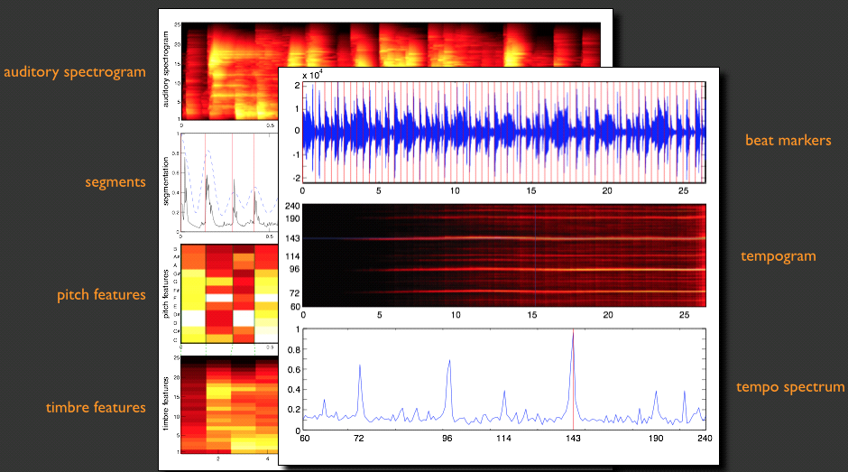

Figure 5.3 Acoustic analysis

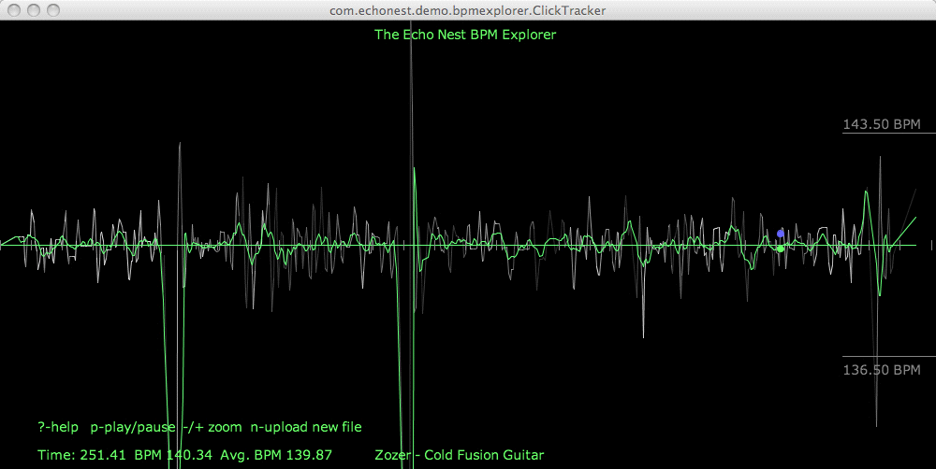

Figure 5.4 Acoustic analysis

The acoustic analysis plays a huge rule in Echo Nest algorithms.

The Echo Nest audio analysis engine contains a suite of machine listening processes that can take any audio file and output both low-level (such as the time of when every beat starts), and high-level (such as the overall “ dance ability ”) information for any song in the world.

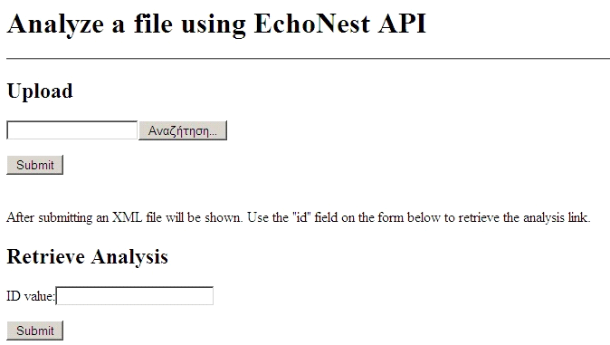

Figure 5.5

## 5.3 Echo Nest API

Echo Nest is a music intelligence platform that has collected and analyzed data about over two million artists and 35 million songs to generate 5 billion data points which in turn are used to power services like song recommendations, audio fingerprinting, playlist generation and song/artist classification in 220 music apps today .The Echo Nest offers an incredible array of music data and services for developers to build amazing apps and experiences.

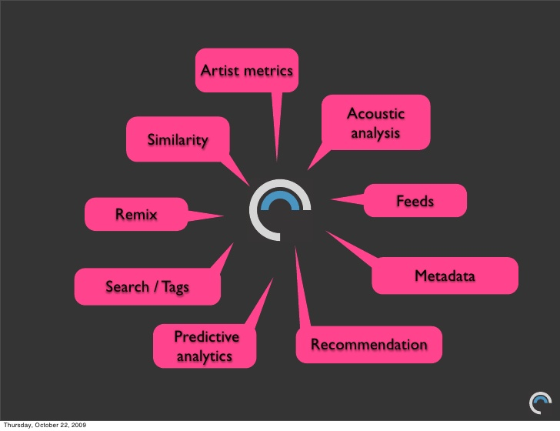

Figure 5.6

In contrast, the Echo Nest approach to identifying similarities in songs for recommendation purposes is two-fold:

1. They analyze music on a purely audio level to extract information like “key”, “tempo”, “timbre”, “beat” etc. This kind of information can enable things like recommendations based on user mood.
2. They exploit the existence of tons of metadata about music (reviews, ratings, tweets, blogs etc.) on the internet and crawl and use this data to determine song similarities on a more cultural level. In a way Echo Nest is acting like a similarity search engine and also has to deal with issues like ranking its metadata sources by importance (like Google).

The Echo Nest API allows you to call methods that respond in JSON or XML. You can call a method by using an HTTP GET to retrieve [http://developer.echonest.com/api/v4/[type]/[method](http://developer.echonest.com/api/v4/%5Btype%5D/%5Bmethod)] along with method specific arguments.

First we must have our API key to use The Echo Nest API.

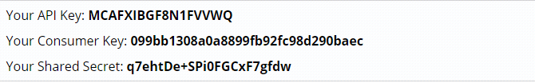

Figure 5.7 MOOJOY API key and Secret.

**In MOOJOY app we use**

* Artist API methods.
* Song API methods.

**5.3.1 Artist API methods**

The Echo Nest provides methods to return a wide range of data about any music artist. For methods that return lists of artists (search, similar).

**5.3.1.1 terms method**

Get a list of most descriptive terms for an artist.

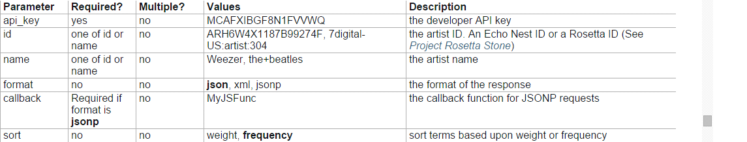

Table5.2 terms method parameters.

Example query

<http://developer.echonest.com/api/v4/artist/terms?api_key=MCAFXIBGF8N1FVVWQ&name=radiohead&format=json>

Response in JSON format

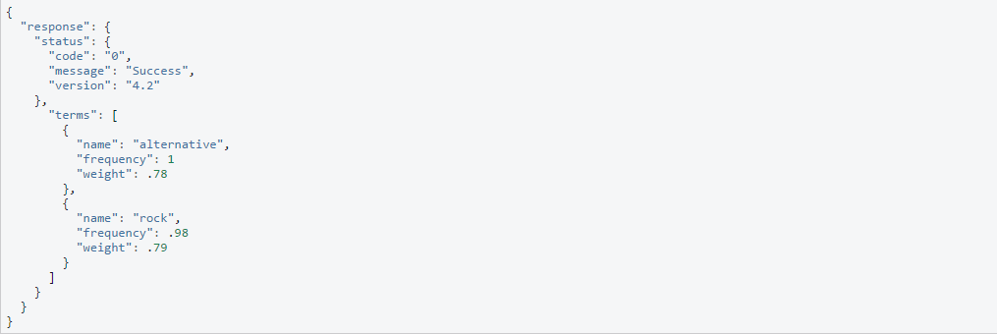

Figure 5.8 terms method response.

**5.3.1.2 Similar method**

Return similar artists given one or more artists for comparison. The Echo Nest provides up-to-the-minute artist similarity and recommendations from their real-time musical and cultural analysis of what people are saying across the Internet and what the music sounds like.

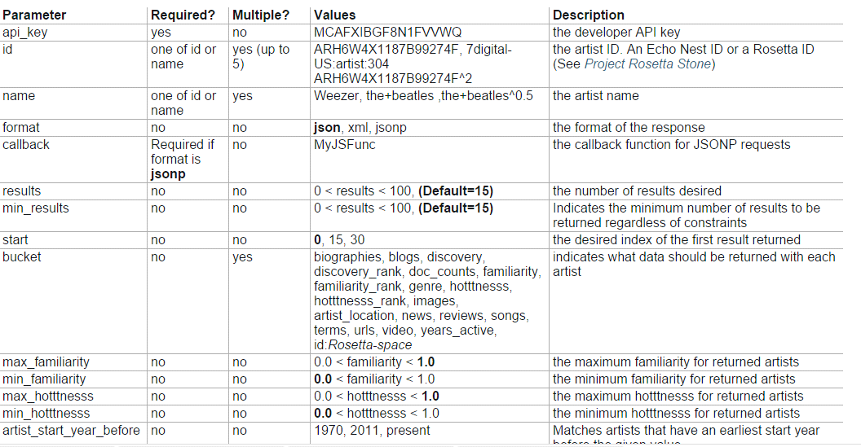

Table 5.3 Similar method parameters.

Example query

<http://developer.echonest.com/api/v4/artist/similar?api_key=MCAFXIBGF8N1FVVWQ&id=ARH6W4X1187B99274F&format=json&results=1>

Response format

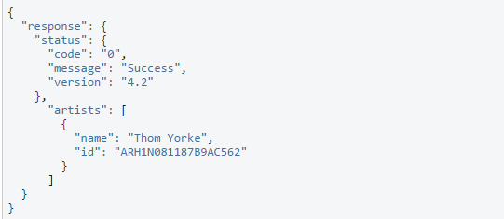

Figure 5.9 Similar method response.

**5.3.1.3 Suggest method**

Suggest artists based upon partial names. This method will return a list of potential artist matches based upon a query string. The method returns the most familiar best matching artist for the query.

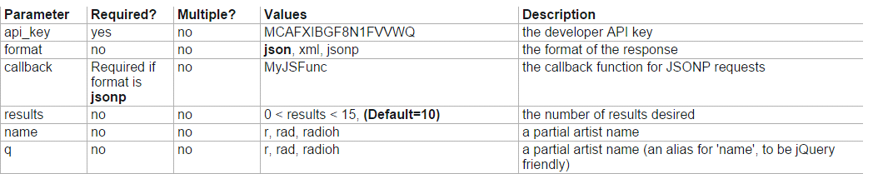

Table5.4 Suggest method parameters.

Example query

<http://developer.echonest.com/api/v4/artist/suggest?api_key=MCAFXIBGF8N1FVVWQ&name=rad&results=5>

Response format

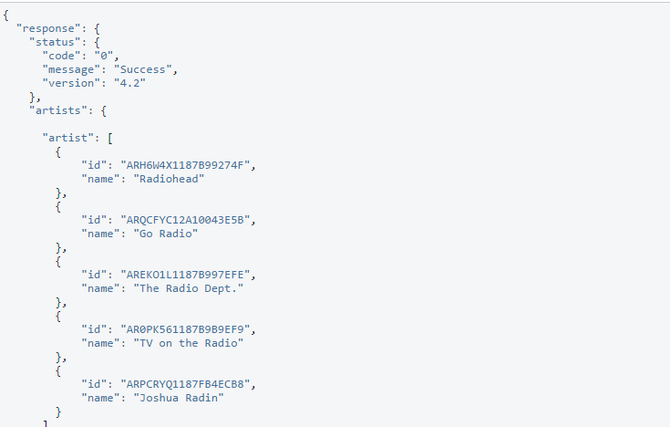

Figure 5.9 Suggest response.

**5.3.1.4 Search method**

Search artists.

Here we can use the user mood , style, artist location or artist description for retrieve a list of artists.

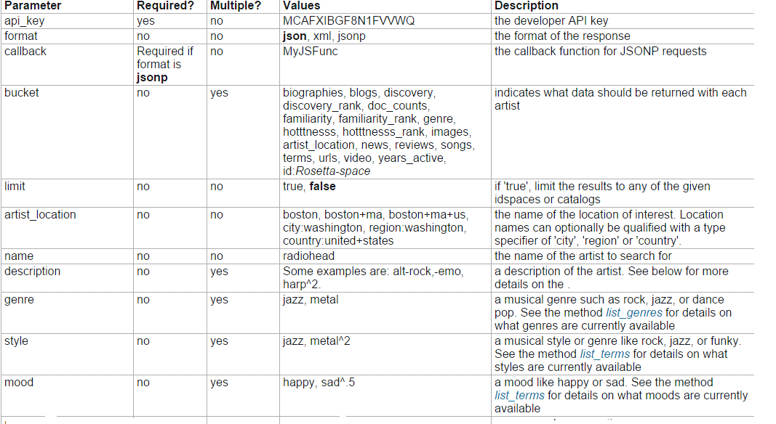

Table5.5 Search method parameter

Example query

<http://developer.echonest.com/api/v4/artist/search?api_key=MCAFXIBGF8N1FVVWQ&format=json&description=heavy&mood=sad&style=jazz&results=1>

Response format

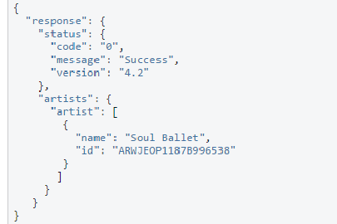

Figure 5.10 Search response

**5.3.1.5 Songs method**

Get a list of songs created by an artist

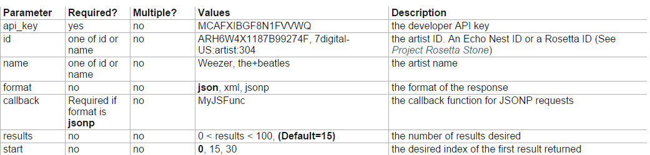

Table 5.6 Songs method parameters.

Example query

<http://developer.echonest.com/api/v4/artist/songs?api_key=MCAFXIBGF8N1FVVWQ&id=ARH6W4X1187B99274F&format=json&start=0&results=2>

Response format

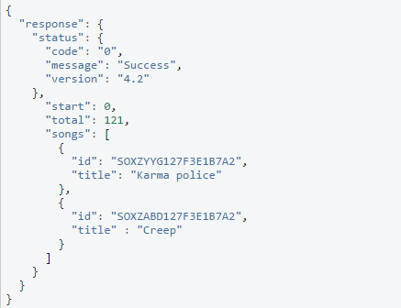

Figure 5.11 Songs method response.

**5.3.2 Song API Method**

API calls for getting data about song

**5.3.2.1 Search Method**

Search for songs given different query types**.**

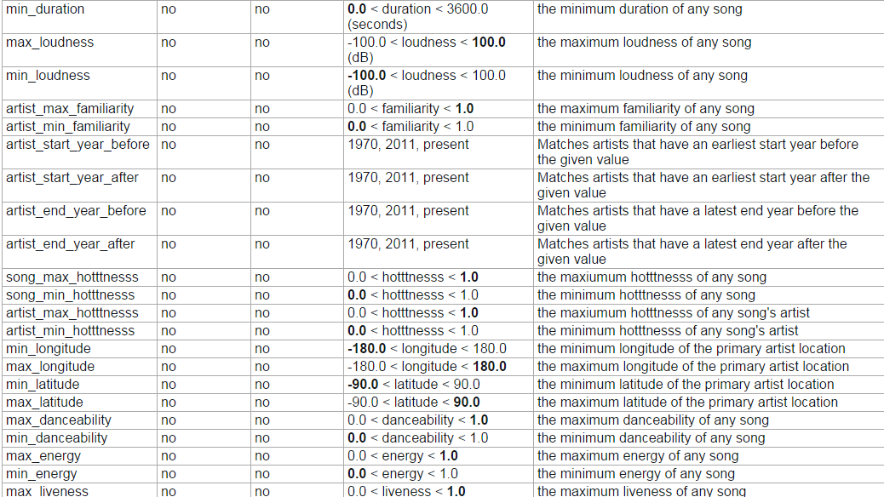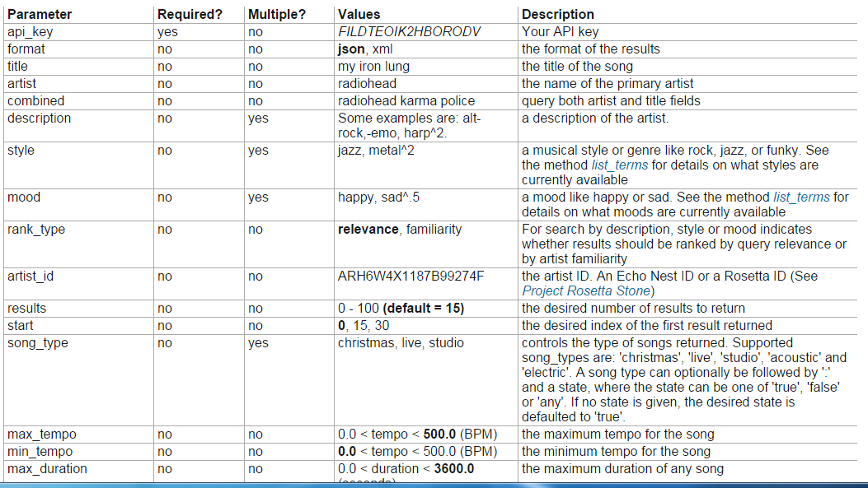

Table 5.7 Search songs method parameters

Example query

<http://developer.echonest.com/api/v4/song/search?api_key=MCAFXIBGF8N1FVVWQ&format=json&results=1&mood=happy>

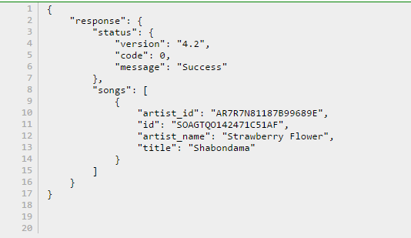

Response format

Figure 5.12 Search songs response

## 5.4 Quotes API

**5.4.1 Random Famous Quotes**

Get a random quote in JSON format according to the current category or mood.

If we send sad mood to our API

**The results**



Figure 5.12

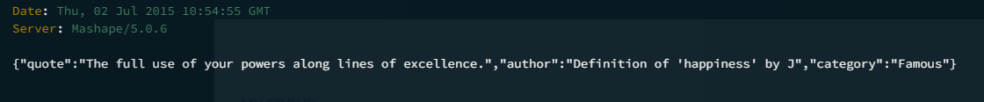

Figure 5.13



Figure 5.14

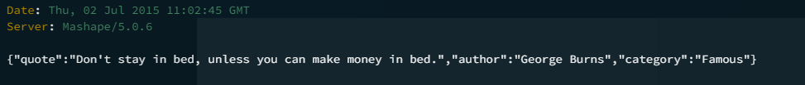

Figure 5.15



Figure 5.16

# Chapter 6

# Text Mining

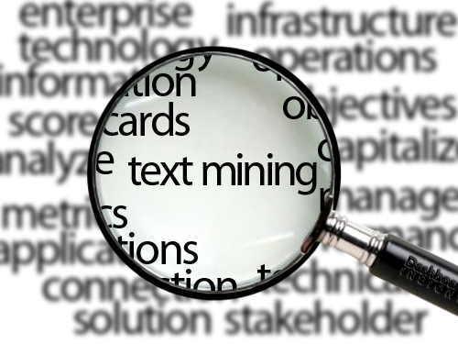

Text Mining is the discovery by computer of new, previously unknown information, by automatically extracting information from different written resources. A key element is the linking together of the extracted information together to form new facts to be explored further by more conventional means of experimentation.

It is different from what we're familiar with in normal search. In search, the user is typically looking for something that is already known and has been written by someone else. The problem is pushing aside all the material that currently isn't relevant to your needs in order to find the relevant information.

The difference between regular data mining and text mining is that in text mining the patterns are extracted from natural language text rather than from structured databases of facts. Databases are designed for programs to process automatically; text is written for people to read.

However, there is a field called computational linguistics (also known as natural language processing) which is making a lot of progress in doing small subtasks in text analysis. For example, it is relatively easy to write a program to extract phrases from an article or book that, when shown to a human reader, seem to summarize its contents.

There are programs that can, with reasonable accuracy, extract information from text with somewhat regularized structure. For example, programs that read in resumes and extract out people's names, addresses, job skills, and so on.

## 6.1 What is text mining?

Text mining is a variation on a field called data mining, which tries to find interesting patterns from large databases. A typical example in data mining is using consumer purchasing patterns to predict which products to place close together on shelves, or to offer coupons for, and so on.

## 6.2 Goals of Text Mining

**First goal:** to discover heretofore unknown information, something that no one yet knows and so could not have yet written down.

**Second goal:** to process unstructured (textual) information, extract meaningful numeric indices from the text, and, thus, make the information contained in the text accessible to the various [data mining](http://documents.software.dell.com/Statistics/Textbook/statistics-glossary/d#data mining) (statistical and machine learning) algorithms. Information can be extracted to derive summaries for the words contained in the documents or to compute summaries for the documents based on the words contained in them. Hence, you can analyze words, clusters of words used in documents, etc., or you could analyze documents and determine similarities between them or how they are related to other variables of interest in the data mining project.

In the most general terms, text mining will "turn text into numbers" (meaningful indices), which can then be incorporated in other analyses such as [predictive data mining](http://documents.software.dell.com/Statistics/Textbook/statistics-glossary/p#predictive data mining) projects.

## 6.3 Text mining and text analytics

The term text analytics describes a set of [statistical](https://en.wikipedia.org/wiki/Statistical), and [machine learning](https://en.wikipedia.org/wiki/Machine_learning) techniques that model and structure the information content of textual sources for [business intelligence](https://en.wikipedia.org/wiki/Business_intelligence), [exploratory data analysis](https://en.wikipedia.org/wiki/Exploratory_data_analysis), [research](https://en.wikipedia.org/wiki/Research), or investigation.

The text analytics term is now used more frequently in business settings while "text mining" is used in some of the earliest application areas. The term text analytics also describes that application of text analytics to respond to business problems, whether independently or in conjunction with query and analysis of fielded, numerical data.

## 6.4 Typical Applications for Text Mining

The technology is now broadly applied for a wide variety of government, research, and business needs. Applications can be sorted into a number of categories by analysis type or by business function. Using this approach to classifying solutions, application categories include:

* Enterprise Business Intelligence/Data Mining, [Competitive Intelligence](https://en.wikipedia.org/wiki/Competitive_Intelligence)
* [E-Discovery](https://en.wikipedia.org/wiki/E-Discovery), Records Management
* [National Security](https://en.wikipedia.org/wiki/National_Security)/Intelligence
* [Scientific discovery](https://en.wikipedia.org/wiki/Scientific_discovery), especially Life Sciences
* [Sentiment Analysis](https://en.wikipedia.org/wiki/Sentiment_Analysis) Tools, Listening Platforms
* Natural Language/Semantic Toolkit or Service
* Publishing
* Automated [ad placement](https://en.wikipedia.org/wiki/Ad_serving)
* Search/Information Access
* [Social media](https://en.wikipedia.org/wiki/Social_media) monitoring

### 6.4.1 Security applications

Many text mining software packages are marketed for [security applications](https://en.wikipedia.org/wiki/Security_appliance), especially monitoring and analysis of online plain text sources such as [Internet news](https://en.wikipedia.org/wiki/Internet_news), [blogs](https://en.wikipedia.org/wiki/Blog), etc. for [national security](https://en.wikipedia.org/wiki/National_security) purposes. It is also involved in the study of text [encryption](https://en.wikipedia.org/wiki/Encryption)/[decryption](https://en.wikipedia.org/wiki/Decryption).

**6.4.2 Biomedical applications**

One online text mining application in the biomedical literature is [PubGene](https://en.wikipedia.org/wiki/PubGene) that combines biomedical text mining with network visualization as an Internet service.

**6.4.3 Software applications**

Text mining methods and software is also being researched and developed by major firms, including [IBM](https://en.wikipedia.org/wiki/IBM) and [Microsoft](https://en.wikipedia.org/wiki/Microsoft), to further automate the mining and analysis processes, and by different firms working in the area of search and indexing in general as a way to improve their results.

**6.4.4 Online media applications**

Text mining is being used by large media companies, such as the [Tribune Company](https://en.wikipedia.org/wiki/Tribune_Company), to clarify information and to provide readers with greater search experiences, which in turn increases site "stickiness" and revenue. Additionally, on the back end, editors are benefiting by being able to share, associate and package news across properties, significantly increasing opportunities to monetize content.

**6.4.5 Marketing applications**

Text mining is starting to be used in marketing as well, more specifically in analytical [customer relationship management](https://en.wikipedia.org/wiki/Customer_relationship_management).

**Sentiment analysis**

[Sentiment analysis](https://en.wikipedia.org/wiki/Sentiment_analysis) may involve analysis of movie reviews for estimating how favorable a review is for a movie. Such an analysis may need a labeled data set or labeling of the [affectivity](https://en.wikipedia.org/wiki/Affect_(psychology)) of words.

Text has been used to detect emotions in the related area of affective computing. Text based approaches to affective computing have been used on multiple corpora such as students evaluations, children stories and news stories.

## 6.5 Approaches to Text Mining

Text mining can be summarized as a process of "numericizing" text. At the simplest level, all words found in the input documents will be indexed and counted in order to compute a table of documents and words, i.e., a matrix of frequencies that enumerates the number of times that each word occurs in each document.

**Using well-tested methods and understanding the results of text mining.** Once a data matrix has been computed from the input documents and words found in those documents, various well-known analytic techniques can be used for further processing those data including methods for clustering, factoring, or predictive data mining.

**Black-box approaches to text mining and extraction of concepts.** There are text mining applications which offer "black-box" methods to extract "deep meaning" from documents with little human effort (to first read and understand those documents). These text mining applications rely on proprietary algorithms for presumably extracting "concepts" from text, and may even claim to be able to summarize large numbers of text documents automatically, retaining the core and most important meaning of those documents.

**Text mining as document search.** There is another type of application that is often described and referred to as "text mining" - the automatic search of large numbers of documents based on key words or key phrases. This is the domain of, for example, the popular internet search engines that have been developed over the last decade to provide efficient access to Web pages with certain content.

## 6.6 Text Mining Algorithms

10 data mining algorithms identified by the IEEE International Conference on Data Mining (ICDM) and these top 10 algorithms are among the most influential data mining algorithms in the research community.

## C4.5

## ****What does it do**?**C4.5 constructs a classifier in the form of a decision tree.

1. **k-means**

**What does it do?**K-means creates  groups from a set of objects so that the members of a group are more similar. It’s a popular cluster analysis technique for exploring a dataset.

## 3. Support vector machines

**What does it do?**Support vector machine (SVM) learns a hyperplane to classify data into 2 classes. At a high-level, SVM performs a similar task like C4.5 except SVM doesn’t use decision trees at all.

## 4. Apriori

**What does it do?**The Apriori algorithm learns association rules and is applied to a database containing a large number of transactions.

## 5. EM

**What does it do?**In data mining, expectation-maximization (EM) is generally used as a clustering algorithm (like k-means) for knowledge discovery.

## 

## 6. PageRank

**What does it do?**PageRank is a link analysis algorithm designed to determine the relative importance of some object linked within a network of objects.

## 7. AdaBoost

**What does it do?**AdaBoost is a boosting algorithm which constructs a classifier.

## 8. kNN

**What does it do?**kNN, or k-Nearest Neighbors, is a classification algorithm. However, it differs from the classifiers previously described because it’s a lazy learner.

## 9. Naive Bayes

**What does it do?**Naive Bayes is not a single algorithm, but a family of classification algorithms that share one common assumption:

Every feature of the data being classified is independent of all other features given the class.

**What does independent mean?** 2 features are independent when the value of one feature has no effect on the value of another feature.

For example:

Let’s say you have a patient dataset containing features like pulse, cholesterol level, weight, height and zip code. All features would be independent if the value of all features has no effect on each other. For this dataset, it’s reasonable to assume that the patient’s height and zip code are independent, since a patient’s height has little to do with their zip code.

But let’s not stop there, are the other features independent?

Sadly, the answer is no. Here are 3 feature relationships which are not independent:

* If height increases, weight likely increases.
* If cholesterol level increases, weight likely increases.
* If cholesterol level increases, pulse likely increases as well.

**Why is it called naive?**The assumption that all features of a dataset are independent is precisely why it’s called naive — it’s generally not the case that all features are independent.

**What’s Bayes?** Thomas Bayes was an English statistician for which Bayes’ Theorem is named after. You can click on the link to find about more about [Bayes’ Theorem](http://en.wikipedia.org/wiki/Bayes%27_theorem).

In a nutshell, the theorem allows us to predict the class given a set of features using probability.

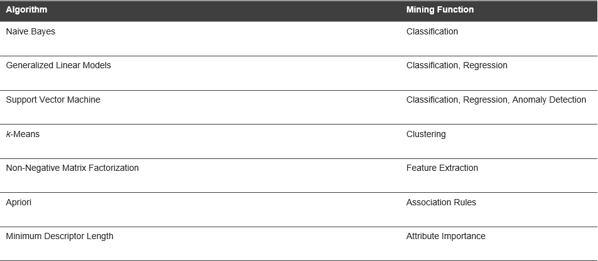Table 6.1 Text mining Algorithms

## 6.6 Text Classification

Text classification is the process of categorizing documents: for example, by subject or author. Most document classification applications use either multi-class classification or multi-target classification.

#### Multi-Class Document Classification

In multi-class document classification, each document is assigned a probability for each category, and the probabilities add to 1. For example, if the categories are economics, math, and physics, document A might be 20% likely to be economics, 50% likely to be math, and 30% likely to be physics. This approach to document classification is supported by Oracle Data Mining and by Oracle Text.

#### Multi-Target Document Classification

In multi-target document classification, each document is assigned a probability for either being in a category or not being in a category, and the probabilities for each category add to 1. Given categories economics, math, and physics, document A might be classified as: 30% likely to be economics and 70% likely not to be economics; 65% likely to be math and 35% likely not to be math; 40% likely to be physics and 60% likely not to be physics.

This approach to document classification is supported by Oracle Text but not by Oracle Data Mining. However, you can obtain similar results by building a single binary classification model for each category and then scoring all the models separately in a single SQL scoring query.

# Chapter 7

# Back End

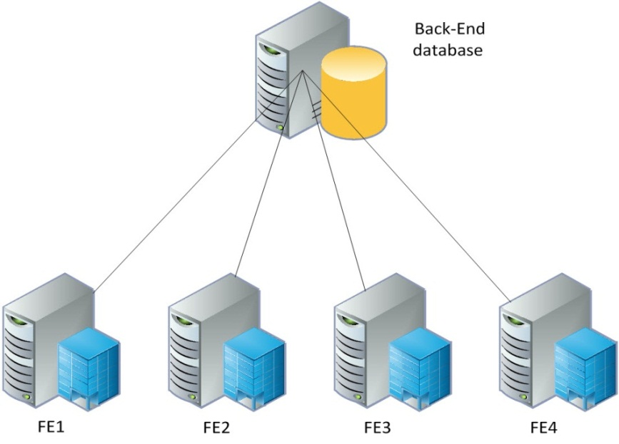

## 7.1 API6 - application programming interface

API*, an* abbreviation ofapplication**p**rogram**interface a** set [routines](http://www.webopedia.com/TERM/R/routine.html), [protocols](http://www.webopedia.com/TERM/P/protocol.html), and tools for building [software applications](http://www.webopedia.com/TERM/A/application.html). The API specifies how software components should interact and APIs are used when programming graphical user interface ([GUI](http://www.webopedia.com/TERM/G/Graphical_User_Interface_GUI.html)) components.  A good API makes it easier to develop a [program](http://www.webopedia.com/TERM/P/program.html) by providing all the building blocks. A [programmer](http://www.webopedia.com/TERM/P/programmer.html) then puts the blocks together.



Figure 7.1

## 7.1.1 Types of APIs

There are many different types of APIs for operating systems, applications or for websites. Windows, for example, has many [API sets](http://msdn.microsoft.com/en-us/library/windows/desktop/hh802935%28v=vs.85%29.aspx) that are used by system hardware and applications — when you copy and paste text from one application to another, it is the API that allows that to work.

Most [operating environments](http://www.webopedia.com/TERM/O/operating_environment.html), such as [MS-Windows](http://www.webopedia.com/TERM/M/MS_Windows.html), provide an API so that programmers can write applications consistent with the operating environment. Today, APIs are also specified by websites. For example, Amazon or eBay APIs allow developers to use the existing retail infrastructure to create specialized web stores. Third-party software developers also use Web APIs to create software solutions for end-users.

## Popular API Examples

[Programmable Web](http://www.programmableweb.com/), a site that tracks more than 13,000 APIs, lists Google Maps, Twitter, YouTube, Flickr and Amazon Product Advertising as some of the the most popular APIs. The following list contains several examples of popular APIs:

1. [**Google Maps API**](https://developers.google.com/maps/)**:** Google Maps APIs lets developers embed Google Maps on webpages using a JavaScript or Flash interface. The Google Maps API is designed to work on mobile devices and desktop browsers.

2. [**YouTube APIs**](https://developers.google.com/youtube/)**:** YouTube API: Google's APIs lets developers integrate YouTube videos and functionality into websites or applications. YouTube APIs include the YouTube Analytics API, YouTube Data API, YouTube Live Streaming API, YouTube Player APIs and others.

3. [**Flickr API**](http://www.flickr.com/services/api/)**:** The Flickr API is used by developers to access the Flick photo sharing community data. The Flickr API consists of a set of callable methods, and some API endpoints.

4. [**Twitter APIs**](https://dev.twitter.com/): Twitter offers two APIs. The REST API allows developers to access core Twitter data and the Search API provides methods for developers to interact with Twitter Search and trends data.

5. [**Amazon Product Advertising API**](https://affiliate-program.amazon.com/gp/advertising/api/detail/main.html): Amazon's Product Advertising API gives developers access to Amazon's product selection and discovery functionality to advertise Amazon products to monetize a website.

**Restful API**

Representational State Transfer (REST) is a [software architecture style](https://en.wikipedia.org/wiki/Software_architecture_styles_and_patterns) consisting of guidelines and best practices for creating [scalable](https://en.wikipedia.org/wiki/Scalability) [web services](https://en.wikipedia.org/wiki/Web_service). REST is a coordinated set of constraints applied to the design of components in a distributed [hypermedia](https://en.wikipedia.org/wiki/Hypermedia) system that can lead to a more performant and maintainable [architecture](https://en.wikipedia.org/wiki/Software_architecture).

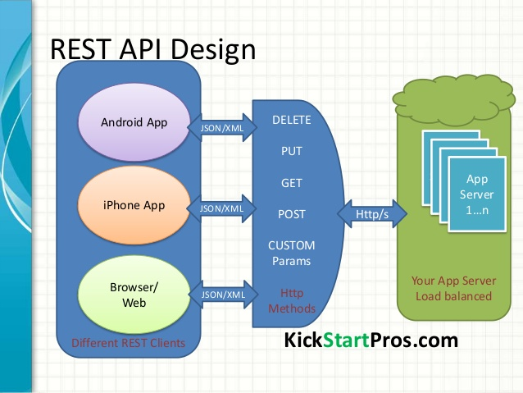

Figure 7.2

REST is the underlying architectural principle of the web. The amazing thing about the web is the fact that clients (browsers) and servers can interact in complex ways without the client knowing anything beforehand about the server and the resources it hosts. The key constraint is that the server and client must both agree on the media used, which in the case of the web is HTML.

An API that adheres to the principles of *REST* does not require the client to know anything about the structure of the API. Rather, the server needs to provide whatever information the client needs to interact with the service. An *HTML form* is an example of this: The server specifies the location of the resource, and the required fields.

 The browser doesn't know in advance where to submit the information, and it doesn't know in advance what information to submit. Both forms of information are entirely supplied by the server.

So, how does this apply to HTTP, and how can it be implemented in practice? HTTP is oriented around verbs and resources. The two verbs in mainstream usage are GET and POST, which I think everyone will recognize. However, the HTTP standard defines several other such as PUT and DELETE. These verbs are then applied to resources, according to the instructions provided by the server.

Notice that we are using different HTTP verbs (GET, PUT, POST, DELETE) to manipulate these resources, and that the only knowledge we presume on the clients part is our media definition.

**7.1.2 Architectural Properties**

The architectural properties affected by the constraints of the REST architectural style are:

* Performance - component interactions can be the dominant factor in user-perceived performance and network efficiency.
* [Scalability](https://en.wikipedia.org/wiki/Scalability) to support large numbers of components and interactions among components**.**
* Simplicity of [interfaces](https://en.wikipedia.org/wiki/Interface_(computer_science))
* The modifiability of components to meet changing needs (even while the application is running)
* Visibility of communication between components by service agents.
* Portability of components by moving program code with the data.
* [Reliability](https://en.wiktionary.org/wiki/reliability) is the resistance to failure at the system level in the presence of failures within components, connectors, or data.

**7.1.3 Architectural Constraints**

The architectural properties of REST are realized by applying specific interaction constraints to components, connectors, and data elements.The formal REST constraints are:

### Client–server

A uniform interface separates clients from servers. This [separation of concerns](https://en.wikipedia.org/wiki/Separation_of_concerns) means that, for example, clients are not concerned with data storage, which remains internal to each server, so that the [portability](https://en.wikipedia.org/wiki/Software_portability) of client code is improved. Servers are not concerned with the user interface or user state, so that servers can be simpler and more [scalable](https://en.wikipedia.org/wiki/Scalability). Servers and clients may also be replaced and developed independently, as long as the interface between them is not altered.

### Stateless

The client–server communication is further constrained by no client context being stored on the server between requests. Each request from any client contains all the information necessary to service the request, and session state is held in the client. The session state can be transferred by the server to another service such as a database to maintain a persistent state for a period and allow authentication. The client begins sending requests when it is ready to make the transition to a new state. While one or more requests are outstanding, the client is considered to be in transition. The representation of each application state contains links that may be used the next time the client chooses to initiate a new state-transition.

### Code on demand

Servers can temporarily extend or customize the functionality of a client by the transfer of executable code.

**Applied to Web Services**

Web service APIs that adhere to the [REST architectural constraints](https://en.wikipedia.org/wiki/Representational_state_transfer#Architectural_constraints) are called [RESTful APIs](https://en.wikipedia.org/w/index.php?title=RESTful_APIs&action=edit&redlink=1). HTTP based RESTful APIs are defined with these aspects:

* Base [URI](https://en.wikipedia.org/wiki/URI), such as http://example.com/resources/
* An [Internet media type](https://en.wikipedia.org/wiki/Internet_media_type) for the data. This is often [JSON](https://en.wikipedia.org/wiki/JSON) but can be any other valid Internet media type (XML, Atom, microformats, images).
* Standard [HTTP methods](https://en.wikipedia.org/wiki/HTTP_method) (e.g., GET, PUT, POST, or DELETE).
* Hypertext links to reference state.
* Hypertext links to reference related resources.

## 7.2 APIs which we used in our App

* **Sky Biometry API**

It introduces cloud-based Face Detection and Recognition API. At the core of the product is one of the world's best algorithms for the detection and recognition of faces that is successfully used in many commercial products around the globe.

This API uses **REST** interface. In general, it means that API methods are called over the internet, using standard **HTTP** methods like GET and POST to[api.skybiometry.com/fc/](http://api.skybiometry.com/fc/). This means that there is no restriction to choosing a programming language for development, as long as it supports HTTP communication. We have also prepared some client-side communication implementations for widely spread language.



* **Echo Nest API**

The Echo Nest was a music intelligence and data platform for developers and media companies.

The Echo Nest API allows you to call methods that respond in

JSON or XML. Individual methods are detailed in the menu on the left. You can call a method by using an HTTP GET to retrieve http://developer.echonest.com/api/v4/[type]/[method] along with method specific arguments.

## 7.3 Laravel

Laravel is a free, open source PHP web application framework, created by Taylor Otwell and intended for the development of web applications following the model –view-controller (MVC) architecture pattern. Laravel strives to make the entire PHP development experience delightful, including your local development environment.

Vagrant provides a simple elegant way to manage and provision Virtual Machines .Laravel utilizes Composer to manage its dependencies. Composer is a tool for dependency management in PHP. It allows you to declare the libraries your project depends on and it will manage (install/update) them.

Laravel makes connecting with databases and running queries extremely simple across a variety of database back-ends using either raw SQL, Laravel supports four database systems:

* MySQL
* Postgres
* SQLite
* SQL Server

Laravel Homestead is an official, pre-packaged Vagrant "box" that provides you a wonderful development environment without requiring you to install PHP, HHVM, a web server, and any other server software on your local machine.

## 7.4 Services in our App

|  |  |  |
| --- | --- | --- |
| **Service** | **Input** | **Output** |
| log-in  We use this service to log-in the app by using Facebook SDK to authenticate with Facebook by using App ID. The user log-in by using e-mail of Facebook if they don't match the e-mail of the Facebook, it gives the user a message with wrong email, and else it retrieves the user id, access token, first name, last name and URL of profile picture. | E-mail. | user name |
| Search  This service is for searching users and their accounts. | User name, first name and last name. | Users and their profile pictures with this name. |
| Follow the user  This service is for following any user and adds him/her to your following list. | User name and friend name. | User id and his friend id will be added to DB. |
| Unfollow the user  This service is for deleting a user from your list. | User id and friend id. | The friend id and user id will be deleted from the database. |
| Followers  This service is for retrieving all users that follow this user (you). | The user name. | Retrieving all his/her followers. |
| Following  This service is for retrieving all users that this user (you) follows. | The user name. | Retrieving all users that he/she follows. |
| show your profile  This service is for showing your profile and information about you such as followers, following, first name, last name and the bio. | User name. | User name, first name, last name, profile picture, bio, following and followers. |
| show another user 's profile  This service is for showing others profiles and their information about them such as followers, following, first name ,last name, state if you follow each other or not and the bio. |  |  |
| edit profile  This service is for editing your profile information such as your first name, last name and the bio. | All information of user such as first name, last name and bio. | Updated data such as updated first name, updated last name and updated bio. |
| Add sample music  This service is for adding initial values of songs for the recommendation system to extract artist and title of the song. | Selected samples (songs). | From the recommendation system we extract artist and title of the song and insert them. |
| Delete sample  This service is for deleting samples which users selected to add for extracting artist and title of the song. | Unselect samples (songs). | Removing artist and title of the song. |
| state of the user  This service is for knowing if these users are following each other or not. | User name and friend name. | State if they follow each other or not. |
| Timeline  This service is for showing the timeline of the user, his/her posts and friend's posts. | User name. | Posts ordered by date. |
| Post mood  This service is for users who exactly knows there moods. | User name and mood. | Insert post with selected mood. |
| Emotion detection by camera.  This service is for users who uses camera to detect their moods.  They take picture by camera and send this picture to the API to detect the mood then make post by this detected mood. | User name and picture took by mobile camera. | Mood and making post by this mood. |
| favorite post  This service is for letting the user favorite the post or not. | Post id and user name. | Increase favorite counter of the post. |
| Delete post  This service is for deleting posts if you don't want it to be in your timeline and others timeline. | Post id and user name. | Delete post. |
| log-out  This service ends the authentication of this user. |  |  |

Table 7.1 Services

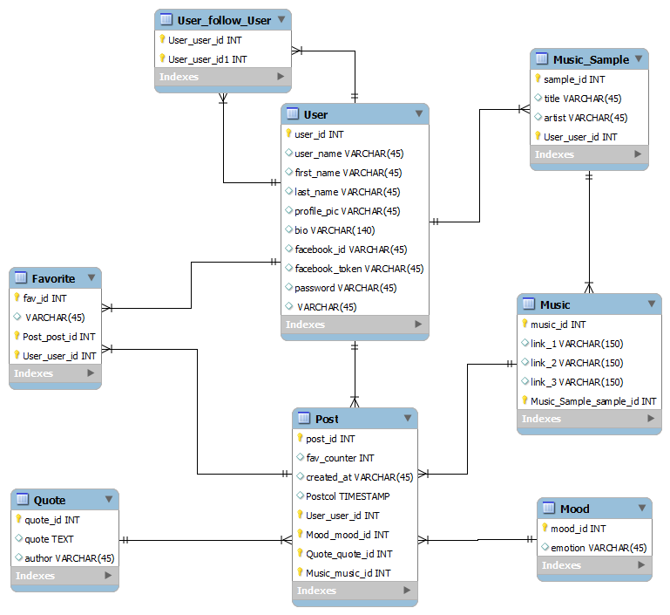**7.5** ERD

Figure 7.5 ERD

# Chapter 8

# Competitors

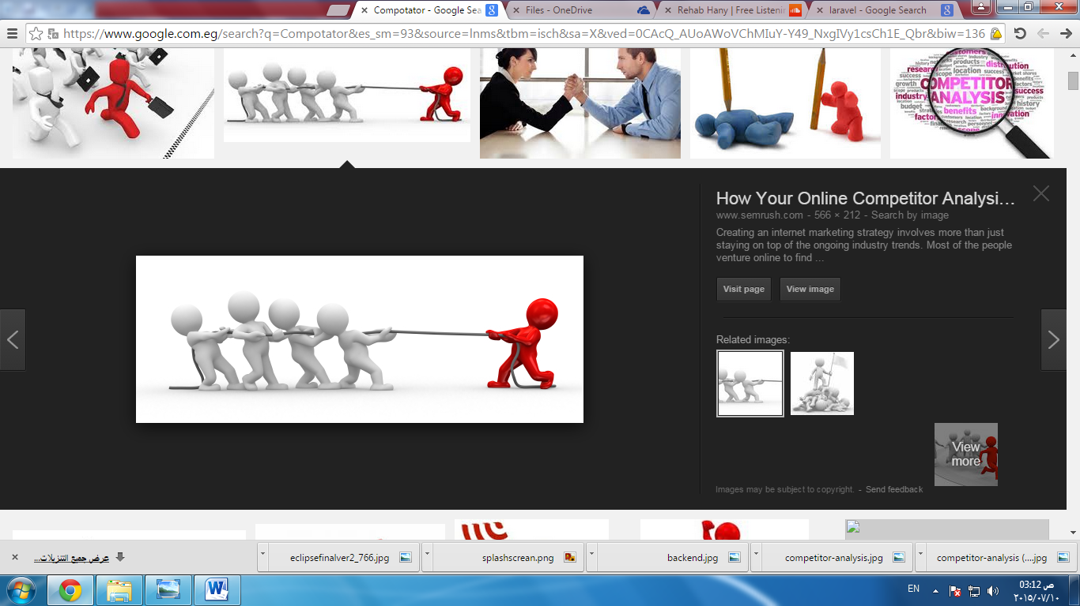

**Face Mood Scanner**

Face Mood scanner can detect your mood by taking a picture of you from the camera. This is a must have android app. This is way better than a thumb mood scanner, because this scans your face, not the thumb.   
Use Mood Scanner to test your friends, family member's or someone else's feelings. Compare their mood with your own and find out who is in a better or worse mood.

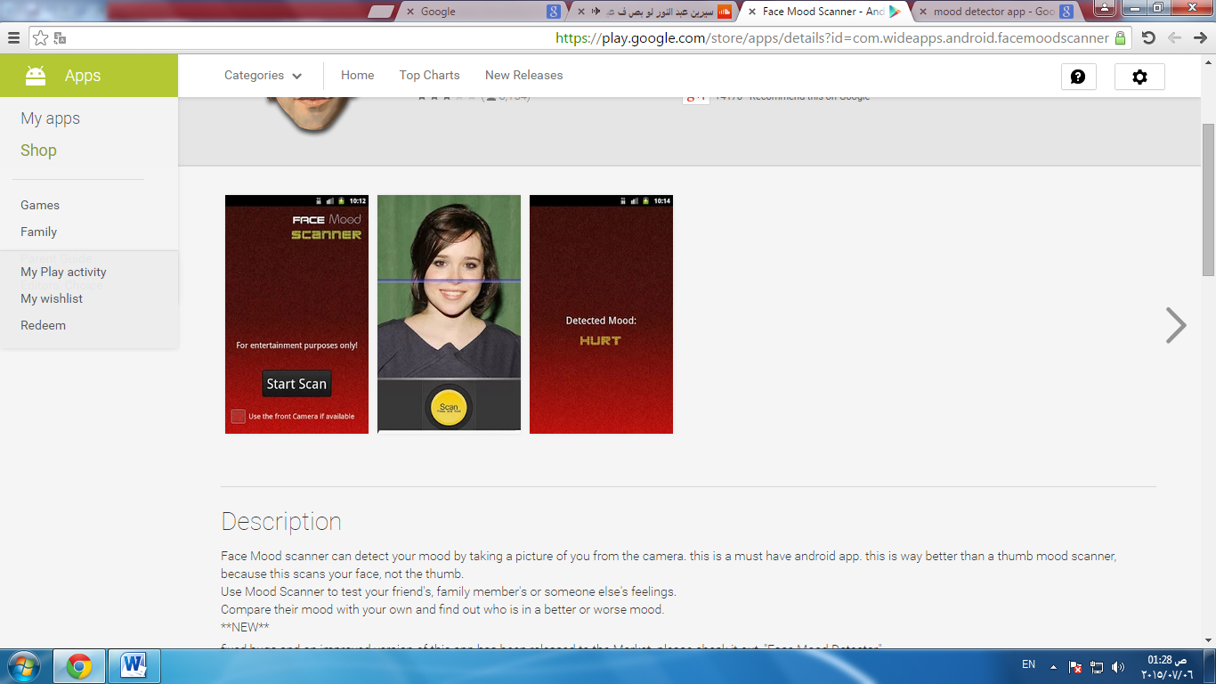

Figure 8.1

**Face Mood Scanner**

Mood scanner is a cool mood detection futuristic fingerprint scanner and face scanner that attempts to determine how you are feeling based on your facial expressions Simply choose your face on the scanning pad, wait for the scan and calculation to complete, and see what the app shows about you or your friend’s mood

* Great application for playing jokes on your friends and family.
* Has a realistic scan bar that makes it look like it's actually reading your print
* Many mood types - happy, in love, excited, sad, and many more.
* More than 100 moods
* Camera scan animation

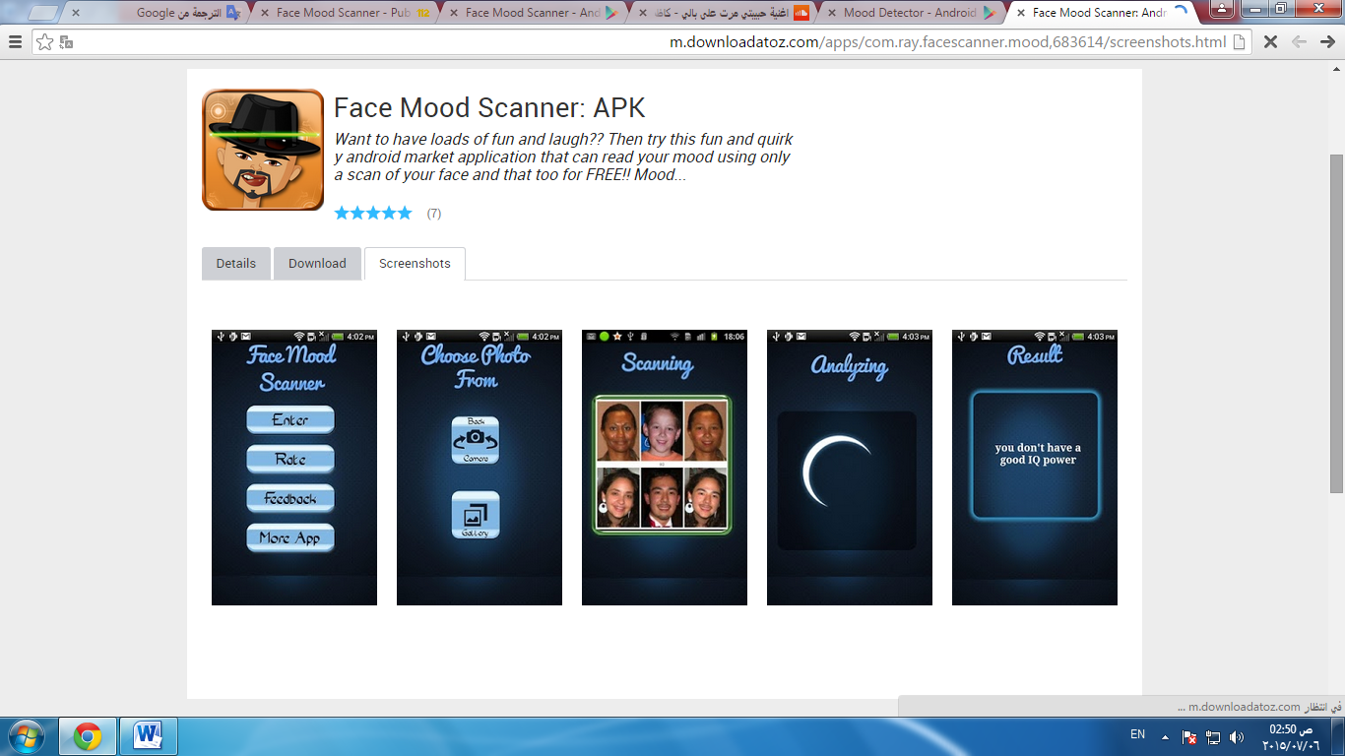Figure 8.2

Face Mood Scanner is for entertainment purposes only, and does not actually scan or does face detection for real. This is a just a fun app and do not expect it to give accurate results

.

**Mood Scanner HD**

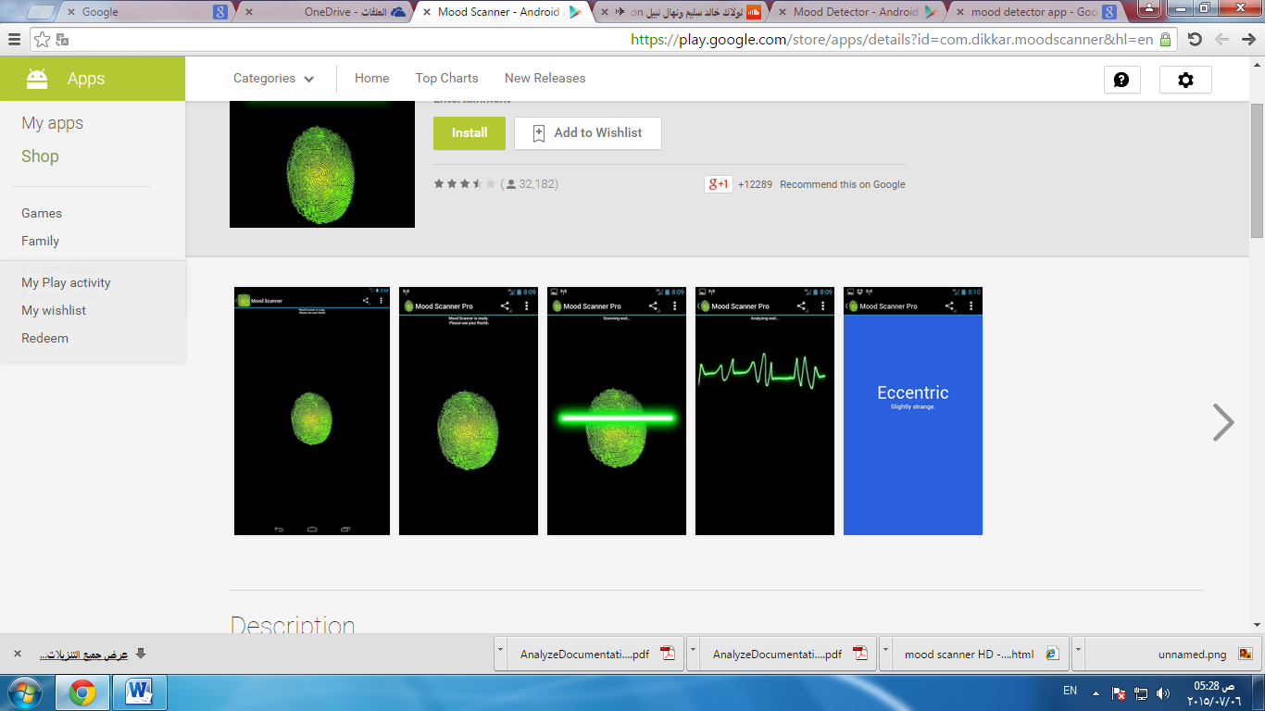Mood Scanner HD is a fun and entertaining App which scans your thumb and detects your mood. It acts as a mood sensor similar to mood rings.

Figure 8.3

**Features**

* Use more than 80 mood.
* More than five algorithms to analyze the mood.

**MOOJOY**

MOOJOY is an Android mobile application that detects mood by capturing image of the current user and then recommends a suitable songs and quotes based on what Characteristic of his favorite artists.

**Our scenario**

* MOOJOY uses Facebook account to register for MOOJOY.

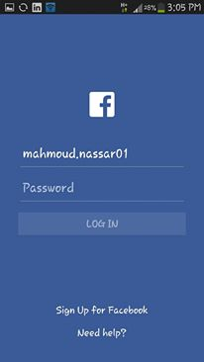

* User can select his favorite songs from his playlist on devise.

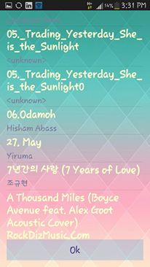

* User clicks on scan mood button to open camera to detect his mood or choose his mood direct from emotions list.

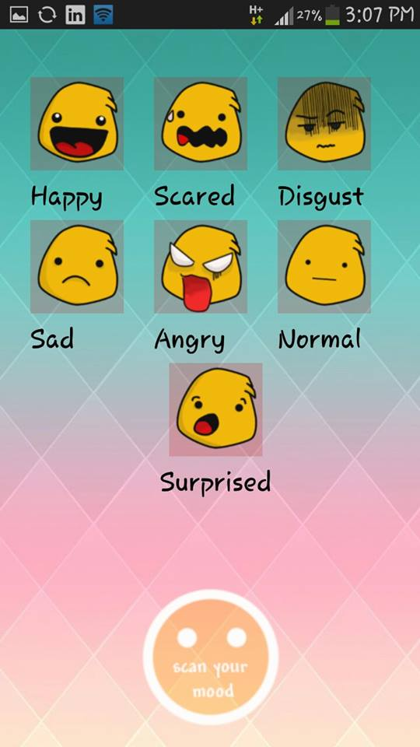

* Mood Is Posted in his timeline contains recommended songs and quotes.
* User can like his friend’s posts and unlike it.

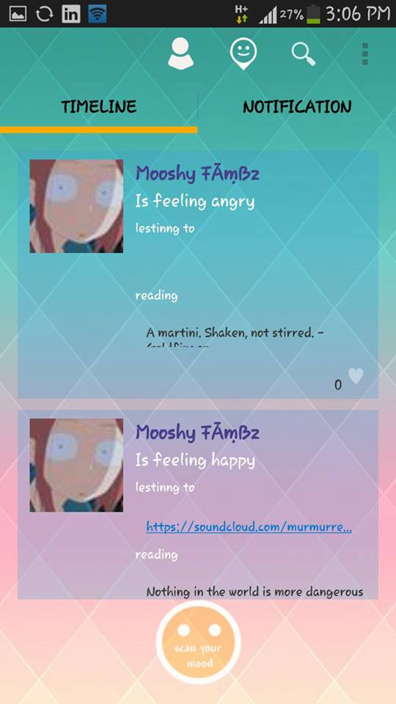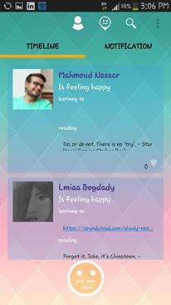

* 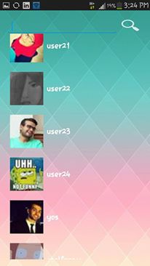Users can search and follow each other’s.

* User can edit his profile.

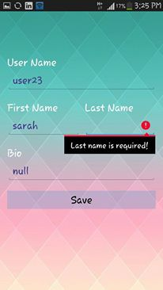

# Chapter 10

# Experiments results

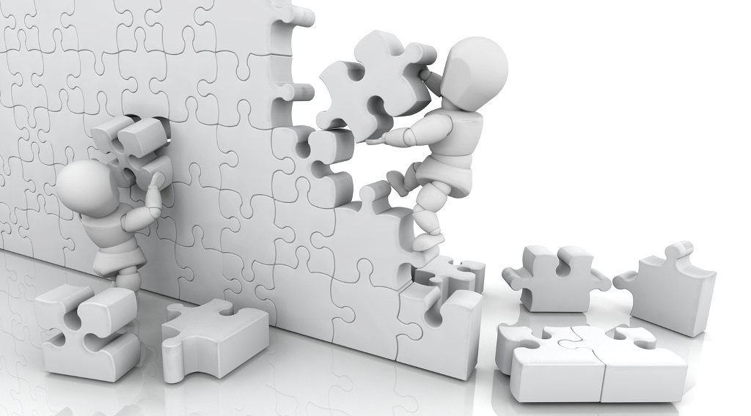

## 10.1 Snapdragon results

|  |  |  |  |  |  |  |  |  |  |  |  |  |  |  |  |  |  |  |  |  |  |
| --- | --- | --- | --- | --- | --- | --- | --- | --- | --- | --- | --- | --- | --- | --- | --- | --- | --- | --- | --- | --- | --- |
|  | **Happy** | | | | **Sad** | | **Bored** | | **Normal** | | **Surprise** | | | | **Angry** | | | **Sleepy** | | | |
| 1 | | 2 | | 1 | | 2 | | 1 | | 2 | |
| Smile Value | 43 | | 47 | | 6 | | 2 | | 30 | | 13 | | 9 | | 1 | | | 2 | | 3 | |
| Face Yaw Value | 5 | | 3 | | 5 | | 8 | | -2 | | -4 | | -5 | | 3 | | | -1 | | 0 | |
| Face Pitch Value | -5 | | -1 | | -1 | | -8 | | -2 | | -1 | | 16 | | -15 | | | -8 | | 3 | |
| Horizontal Gaze | 0 | | -1 | | 2 | | -1 | | 1 | | 2 | | 1 | | -6 | | | -2 | | -3 | |
| Vertical Gaze | -12 | | -11 | | -12 | | -5 | | -9 | | -18 | | -9 | | -1 | | | -8 | | -22 | |
| Gaze Point | 0.0 | 0.34 | -0.03 | 0.32 | 0.06 | 0.3  4 | -0.  0  3 | 0.1  4 | 0.  0  3 | 0.2  6 | 0.06 | 0.51 | 0.03 | 0.26 | | -0.17 | 0.03 | -0.06 | 0.23 | -0.09 | 0.62 |
| Mouth Point | 549 | 1144 | 534 | 1030 | 582 | 1  0  0  5 | 5  6  4 | 9  7  2 | 6  0  9 | 1  1  1  4 | 534 | 994 | 594 | 839 | | 537 | 1236 | 573 | 1147 | 561 | 1080 |
| Left Brow Bottom | 666 | 850 | 666 | 761 | 699 | 7  4  2 | 6  8  4 | 7  2  0 | 7  3  8 | 8  3  9 | 651 | 733 | 705 | 592 | | 666 | 953 | 705 | 869 | 693 | 811 |
| Right Brow Bottom | 417 | 858 | 420 | 750 | 471 | 7  3  1 | 4  6  2 | 7  0  0 | 4  8  3 | 8  3  6 | 429 | 736 | 489 | 595 | | 426 | 944 | 462 | 864 | 453 | 811 |
| Left Brow  Top | 663 | 822 | 666 | 736 | 699 | 7  1  7 | 6  8  7 | 6  9  7 | 7  3  8 | 8  1  4 | 651 | 711 | 702 | 570 | | 6  6  9 | 928 | 705 | 844 | 693 | 786 |
| Right Brow Top | 414 | 831 | 423 | 725 | 471 | 7  0  9 | 4  6  5 | 6  7  8 | 4  8  3 | 8  1  1 | 429 | 714 | 492 | 570 | | 4  2  9 | 919 | 465 | 836 | 456 | 786 |
| Left Brow Left | 744 | 847 | 741 | 767 | 717 | 7  4  5 | 7  5  3 | 7  2  0 | 8  1  6 | 8  4  2 | 723 | 739 | 771 | 609 | | 7  4  4 | 947 | 783 | 869 | 771 | 817 |
| Right Brow Left | 330 | 864 | 336 | 753 | 390 | 7  3  3 | 3  8  4 | 6  9  2 | 4  0  5 | 8  3  9 | 363 | 742 | 423 | 609 | | 3  4  8 | 933 | 384 | 856 | 378 | 814 |
| Left Brow Right | 585 | 850 | 588 | 756 | 627 | 7  3  9 | 6  1  2 | 7  1  7 | 6  5  4 | 8  3  9 | 579 | 736 | 636 | 589 | | 5  9  1 | 953 | 627 | 867 | 615 | 808 |
| Right Brow Right | 501 | 856 | 504 | 753 | 549 | 7  3  6 | 5  3  7 | 7  0  9 | 5  6  4 | 8  3  6 | 501 | 739 | 558 | 592 | | 5  0  7 | 950 | 543 | 864 | 528 | 808 |
| Left Eye | 426 | 914 | 429 | 803 | 480 | 7  8  6 | 4  5  9 | 7  4  2 | 5  0  1 | 8  8  9 | 447 | 795 | 504 | 699 | | 4  4  1 | 969 | 474 | 908 | 465 | 867 |
| Right Eye | 663 | 908 | 657 | 814 | 690 | 7  9  5 | 6  6  6 | 7  5  8 | 7  2  3 | 8  8  6 | 645 | 795 | 690 | 659 | | 6  4  8 | 980 | 690 | 914 | 678 | 869 |
| Nose Bridge | 546 | 903 | 546 | 800 | 588 | 7  8  1 | 5  7  3 | 7  4  7 | 6  0  9 | 8  8  1 | 540 | 789 | 597 | 645 | | 5  4  6 | 983 | 582 | 903 | 570 | 858 |
| Nose Center | 549 | 1047 | 540 | 931 | 585 | 9  1  7 | 5  6  4 | 8  9  2 | 6  0  9 | 1  0  2  2 | 540 | 914 | 594 | 758 | | 5  4  0 | 1139 | 579 | 1050 | 564 | 989 |
| Nose Lower Left | 609 | 1044 | 597 | 936 | 633 | 9  1  7 | 6  1  2 | 8  9  2 | 6  6  3 | 1  0  2  2 | 585 | 911 | 639 | 758 | | 5  8  8 | 1141 | 630 | 1050 | 621 | 992 |
| Nose Lower Right | 489 | 1050 | 480 | 931 | 534 | 9  1  7 | 5  1  6 | 8  8  6 | 5  5  5 | 1  0  2  2 | 495 | 914 | 552 | 758 | | 4  9  2 | 1136 | 525 | 1047 | 510 | 989 |
| Nose Upper Left | 567 | 950 | 564 | 844 | 603 | 8  2  5 | 5  8  5 | 7  9  5 | 6  2  7 | 9  2  8 | 555 | 831 | 612 | 684 | | 5  6  1 | 1036 | 597 | 953 | 588 | 903 |
| Nose Upper Right | 528 | 953 | 525 | 844 | 570 | 8  2  5 | 5  5  5 | 7  9  5 | 5  9  1 | 9  2  8 | 525 | 831 | 582 | 684 | | 5  2  8 | 1033 | 564 | 950 | 549 | 903 |
| Nose Middle Left | 588 | 997 | 579 | 892 | 618 | 8  7  2 | 6  0  0 | 8  4  4 | 6  4  5 | 9  7  5 | 570 | 869 | 624 | 720 | | 5  7  3 | 1089 | 615 | 1000 | 60  3 | 947 |
| Nose Middle  Right | 507 | 1000 | 501 | 886 | 552 | 8  7  2 | 5  3  4 | 8  3  9 | 5  7  3 | 9  7  5 | 510 | 872 | 567 | 720 | | 5  1  0 | 1086 | 543 | 1000 | 531 | 944 |
| Nose Tip | 552 | 1017 | 546 | 900 | 588 | 8  8  6 | 5  7  3 | 8  6  9 | 6  1  2 | 9  9  7 | 537 | 878 | 594 | 714 | | 5  4  3 | 1122 | 579 | 1028 | 564 | 955 |
| Chin Center | 558 | 1291 | 522 | 1183 | 576 | 1  1  4  1 | 5  5  8 | 1  0  9  1 | 6  1  5 | 1  2  5  2 | 543 | 1128 | 594 | 994 | | 5  3  1 | 1336 | 570 | 1264 | 558 | 1230 |
| Chin Left | 744 | 1169 | 702 | 1078 | 738 | 1  0  4  4 | 7  1  1 | 9  9  4 | 7  9  5 | 1  1  3  9 | 723 | 1033 | 759 | 917 | | 7  0  8 | 1225 | 750 | 1153 | 756 | 1125 |
| Chin Right | 339 | 1186 | 321 | 1066 | 384 | 1  0  3  6 | 3  7  2 | 9  7  2 | 4  2  3 | 1  1  3  9 | 381 | 1036 | 444 | 919 | | 3  5  4 | 1211 | 384 | 1141 | 381 | 1119 |

Table 10.1

We made focus group on 10 people, and then we discovered all values are very close that is making Difficulty in clustering implement.

So we use skybiometry API to detect mood in effective way.

* Skybiometry API result

1- $response = Unirest\Request::post("https://face.p.mashape.com/faces/detect?api_key=596e85693d2641d4bf39882369d42d40&api_secret=32c4f5ed5dd44e3a99fa69efb5efd751",

array(

"X-Mashape-Key" => "pQ41XILndxmshXlMyYE4RluqMgf9p1iQGLLjsnj7DmcpVioOso",

"Content-Type" => "application/x-www-form-urlencoded",

"Accept" => "application/json"

),

array(

"attributes" => "all",

"detector" => "Aggressive",

"urls" => "http://static.guim.co.uk/sys-images/Guardian/Pix/pictures/2013/12/17/1387241799285/Human-rights-commissioner-010.jpg"

));



Figure 10.1

Response

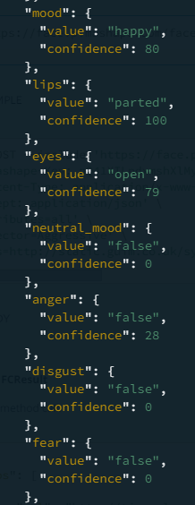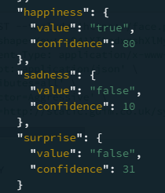

Figure 10.2 Figure 10.3

2-$response = Unirest\Request::post("https://face.p.mashape.com/faces/detect?api_key=596e85693d2641d4bf39882369d42d40&api_secret=32c4f5ed5dd44e3a99fa69efb5efd751",

array(

"X-Mashape-Key" => "pQ41XILndxmshXlMyYE4RluqMgf9p1iQGLLjsnj7DmcpVioOso",

"Content-Type" => "application/x-www-form-urlencoded",

"Accept" => "application/json"

),

array(

"attributes" => "all",

"detector" => "Aggressive",

"urls" => "http://cdn.sheknows.com/articles/2011/01/Upset_woman.jpg"

));



Figure 10.4

Response

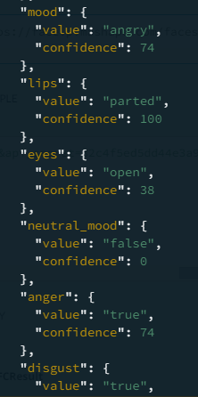 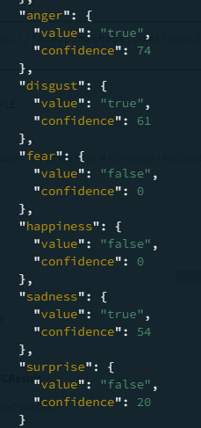

Figure 10.5 Figure 10.6

* 3-$response = Unirest\Request::post("https://face.p.mashape.com/faces/detect?api_key=596e85693d2641d4bf39882369d42d40&api_secret=32c4f5ed5dd44e3a99fa69efb5efd751",

array(

"X-Mashape-Key" => "pQ41XILndxmshXlMyYE4RluqMgf9p1iQGLLjsnj7DmcpVioOso",

"Content-Type" => "application/x-www-form-urlencoded",

"Accept" => "application/json"

),

array(

"attributes" => "all",

"detector" => "Aggressive",

"urls" => "http://greatergood.berkeley.edu/images/uploads/6EAM.jpg"

));

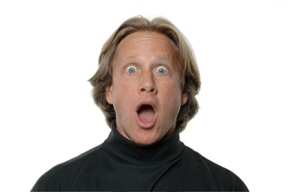

Figure 10.7

Response

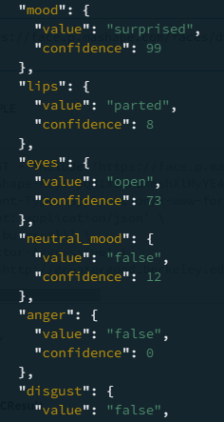 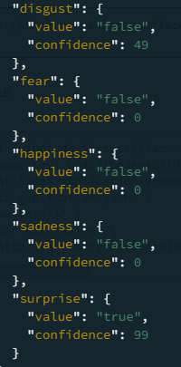

Figure 10.8 Figure 10.9

4-$response = Unirest\Request::post("https://face.p.mashape.com/faces/detect?api_key=596e85693d2641d4bf39882369d42d40&api_secret=32c4f5ed5dd44e3a99fa69efb5efd751",

array(

"X-Mashape-Key" => "pQ41XILndxmshXlMyYE4RluqMgf9p1iQGLLjsnj7DmcpVioOso",

"Content-Type" => "application/x-www-form-urlencoded",

"Accept" => "application/json"

),

array(

"attributes" => "all",

"detector" => "Aggressive",

"urls" => "http://www.tc.columbia.edu/i/media/8311_Faces02.jpg" ));



Figure 10.10

Response

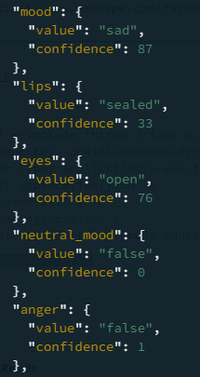 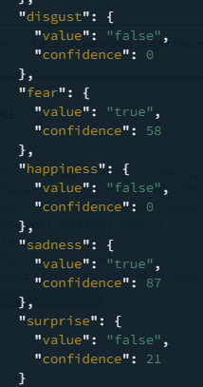

Figure 10.11 Figure 10.12

5-$response = Unirest\Request::post("https://face.p.mashape.com/faces/detect?api_key=596e85693d2641d4bf39882369d42d40&api_secret=32c4f5ed5dd44e3a99fa69efb5efd751",

array(

"X-Mashape-Key" => "pQ41XILndxmshXlMyYE4RluqMgf9p1iQGLLjsnj7DmcpVioOso",

"Content-Type" => "application/x-www-form-urlencoded",

"Accept" => "application/json"

),

array(

"attributes" => "all",

"detector" => "Aggressive",

"urls" => "http://www.capcitydental.co.uk/wp-content/uploads/2014/09/Disgust-240x300.jpg"

)

);



Figure 10.13

Response

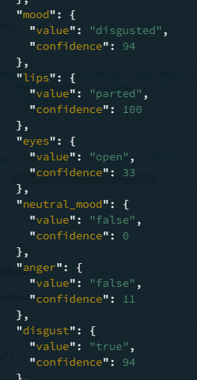 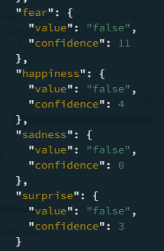

Figure 10.14 Figure 10.15

$response = Unirest\Request::post("https://face.p.mashape.com/faces/detect?api_key=&api_secret=",

array(

"X-Mashape-Key" => "pQ41XILndxmshXlMyYE4RluqMgf9p1iQGLLjsnj7DmcpVioOso",

"Content-Type" => "application/x-www-form-urlencoded",

"Accept" => "application/json"

),

array(

"attributes" => "all",

"detector" => "Aggressive",

"urls" => "http://tinyurl.com/673cksr"

)

);

**Unirest for PHP**

Unirest is a set of lightweight HTTP libraries available in [multiple languages](http://unirest.io/).

## Features

* Utility methods to call GET, HEAD, POST, PUT, DELETE, CONNECT, OPTIONS, TRACE, PATCH requests
* Supports form parameters, file uploads and custom body entities
* Supports zip
* Supports Basic, Digest, Negotiate, NTLM Authentication natively
* Customizable timeout
* Customizable default headers for every request (DRY)
* Automatic JSON parsing into a native object for JSON responses

**X-Mashape-Key**

If you need to list or re-generate your API Key, here are the required steps. Login to Mashape and click on any Application you want to list or change API Key, or you can create a new Application.

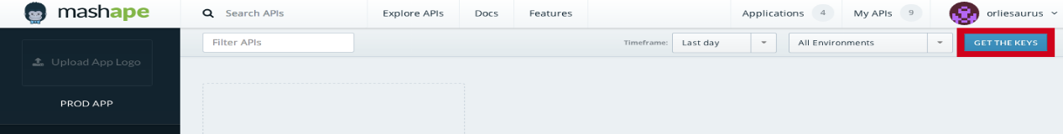Navigate to the Get the Key Button in the Application view.

Figure 10.16

* 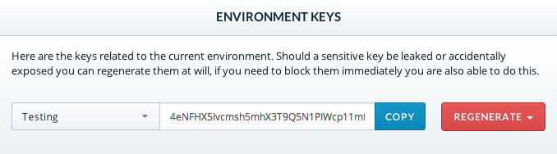Choose which API Key you want to copy or regenerate.

Figure 10.17

**Content-Type => "application/x-www-form-urlencoded"**

This is the default encoding format among HTTP requests.

When using application/x-www-form-urlencoded, the request body being posted will essentially be translated into one long query string. To clarify a potential source of confusion, this data is still being sent through the request body

Form-urlencoded has a low fixed cost, but high variable for special characters, so **application/x-www-form-urlencoded is good for short messages.**

**Accept => "application/json"**

Returned response is in JSON format.

**Attributes**

Specifies which attributes will be returned with the results. Accepted values: all, none or a comma separated list of supported attributes (currently supported attributes are gender, glasses and smiling. face attribute is the default and is always returned regardless of the specified attributes. dark glasses attribute is returned additionally when glasses is requested to differentiate between dark and clear glasses**.**

## 10.2 Text mining results

* **Happy**

|  |  |
| --- | --- |
| **Text** | **Response** |
| I am extremely happy today. | Happy |
| Hug yourself. | Happy |
| Two days left and I’ll finish my exams then we can enjoy together. | Angry |
| I can't describe my feeling right now. | Angry |
| Hey my friend, am feeling am going to fly from happiness, let’s go out today. | Sad |
| It’s like the best day ever. | Happy |
| Hello! I'm overjoyed today!! Something amazing happened. | Happy |
| Hey, I've got some good news, can't wait to tell you. | Bored |
| I really want to celebrate with you. | Bored |
| Thanks for Allah, It is a good day I am very happy. | Happy |
| OMG I’m so happy, did you know what happened! | Happy |
| Thanks god. | Happy |
| WhatsApp dancer, WhatsApp dancer. | Happy |
| I’m so happy. | Happy |
| I will party until death. | Angry |
| That’s my day. | Angry |
| The god loves me. | Sad |
| I had a lovely cat I'm so happy I want you to see it soon my dear. | Happy |
| Hey bro there is an amazing thing happen let’s talks tonight. | Sad |
| Let all of them know, I'm so happy now. | Happy |
| I wish the all be happy like me Yeah. | Happy |
| That's nice, I love it. | Bored |
| I want to fly. | Bored |
| YES YES YES. | Happy |
| Hey friend why you look so sad! Be happy boy it's just a life. | Happy |
| Great, pleased. | Surprise |

Table 10.2

* **Sad**

|  |  |
| --- | --- |
| **Text** | **Response** |
| I’m not feeling good. | Sad |
| I’m sad for some reason & someone tries to cheer me up. | Sad |
| I will when you leave me alone. | Angry |
| I'm feeling a bit sad today, something I don't really like might happen next week. | Sad |
| I need some alone time, I'll talk to you later. | Sad |
| I don't talk when I'm sad. | Sad |
| Oh the things not go straight forward with me, please remember me when you pray. | Sad |
| Hey :( I need a hug. | Sad |
| God please help me please. | Sad |
| This is not my day. | Sad |
| Everything acts against me. | Sad |
| I’m so depressed. | Happy |

Table 10.3

* **Sleepy**

|  |  |
| --- | --- |
| **Text** | **Response** |
| I need a bed now. | Angry |
| If someone tries to wake me up. | Angry |
| What you doing what u want left me alone. | Angry |
| I’m sleepy so I will forget saying half the words. | Sad |
| What are you doing what you want from me, leave me alone. | Angry |
| Hey, so I got to go sleep now, can't keep my eyes open. Talk to you later. | Sleepy |
| Hug your bed. | Sleepy |
| I didn’t sleep for 28 hours because of study. | Bored |
| Going to go. | Bored |
| I'm tired. | Sad |
| I will go to bed now, good night in hope today to be a good one. | Bored |
| Talk to you latter >> nighty | Sad |
| Oh welcome my bed. | Sleepy |
| My bed call me now, I’m going to sleep. | Angry |
| I feel so tired, I have to sleep. | Angry |
| I can't see u now, I will go to sleep. | Angry |
| The earth swing around me, I have to sleep. | Angry |
| I had many things in my list but I'm so lazy I didn’t want to do any routine thing. | Bored |
| But I'm feeling sleepy now, let's talk later. | Sad |

Table 10.4

* **Angry**

|  |  |
| --- | --- |
| **Text** | **Response** |
| I don't say anything when I’m angry I let my expressions do. | Angry |
| No time for that shit if you know me say who you are if you don't fuck off. | Angry |
| I'm so freaking mad right now!! How could you?! | Happy |
| God! It's really annoying. | Surprise |
| Get off my face. | Angry |
| Why don't you do what I told you? | Angry |
| I hate to be angry. | Angry |
| My heart get to be changed when I am angry I hate that. | Angry |
| I always hope to have a pure heart. | Bored |
| Don’t talk to me. | Sad |
| Shut up. | Happy |
| Fuck of | Surprise |
| Where is my phone? I will punish you. Where is fresh fries? , I’m going to eat your meal. I will kill you for lunch if you do not answer me now. Oh my god. | Angry |
| What are you doing? I will kill you for that. | Angry |
| People now wanted to know all thing about others. And this me angry. | Angry |
| Damn... If you do this again I will never talk to you anymore. | Angry |
| Can't talk now, leave me please. | Angry |
| As you like, sorry have to go. | Bored |
| You see that, OK no problem. | Angry |
| Be more patient everything goanna be OK at last. | Angry |
| I won't blame now. | Angry |
| If I talk, things would be more worse believe me. | Angry |

Table 10.5

* **Surprise**

|  |  |
| --- | --- |
| **Text** | **Response** |
| You won't believe what just happened to me. | Surprise |
| Wow! It's freaking amazing. | Surprise |
| OH MY GOD! You won't believe what happened today. | Surprise |
| This is great. | Surprise |
| This is nice. | Surprise |
| I am amazed. | Angry |
| I can't imagine that. | Angry |
| Oh I cannot believe that .I’m surprising .How that can be done. | Surprise |
| OMG!!!! That’s awesome.  Oh my GOD | Surprise  Surprise |
| It's very amazing, thank you very much. | Surprise |
| Oh no oh no oh no, I can't believe. Oh sweet, thank you for that. Look it’s raining. | Surprise |
| My mother bought me a new mobile it’s so surprised. | Sad |
| Wow it's amazing. | Surprise |
| Oh really. | Surprise |
| Seriously | Bored |
| My God. | Bored |
| No no no no. | Surprise |
| No-no it's not. | Surprise |

Table 10.6

* **Bored**

|  |  |
| --- | --- |
| **Text** | **Response** |
| Nothing is going to please me. | Sad |
| Nope I’m bored as hell. | Bored |
| Um... Well. Yeah it's alright. | Surprise |
| I'm bored; do you have anything to watch? | Bored |
| I want to stay in home. | Bored |
| Life sucks. | Bored |
| Life is boring | Bored |
| Want to catch a movie! | Bored |
| Oh I want to get some excitement. | Bored |
| What I can do I hope to travel to anywhere that is very far from here see the sea , beautiful birds, trees and get some silent. | Bored |
| Meh! What are you doing?! | Bored |
| I am out of mode I will go out. | Bored |
| Let’s go for anywhere. | Bored |
| Let’s see a new film. | Bored |
| Let’s go for eating until death. | Bored |
| I’m so bored, let’s kill somebody. | Bored |
| I don't find any new habit; I want anything that I had not tried it before. | Bored |
| Nothing to do... Think about something to kill this boring mood. | Bored |
| I'm going kill you for that. | Bored |
| That's really bored, when to finish? | Bored |
| I'm tired, complete it later. | Bored |
| Be more specific please. | Sad |

Table 10.7

## 10.3 Quotes API results

Sad mood

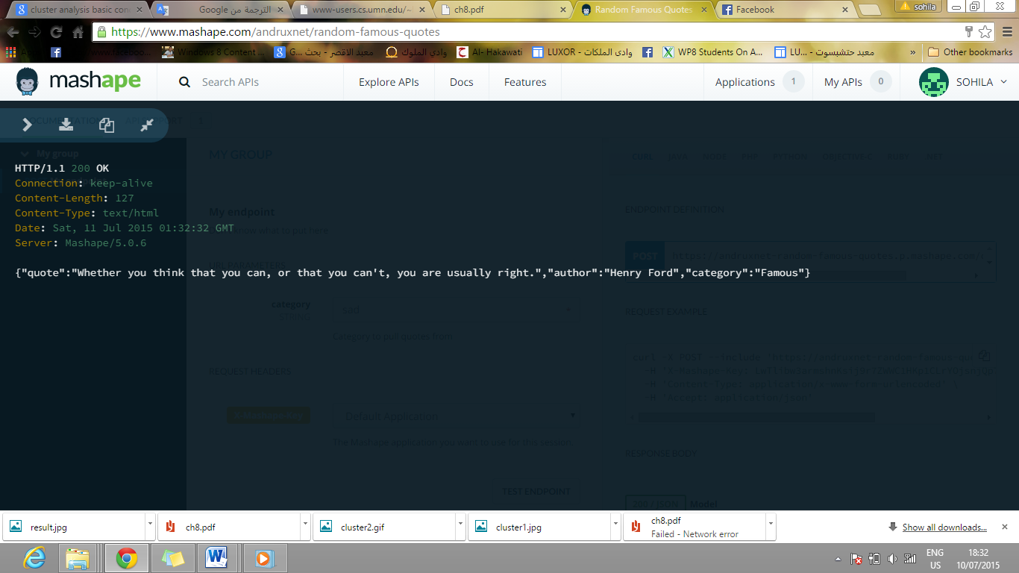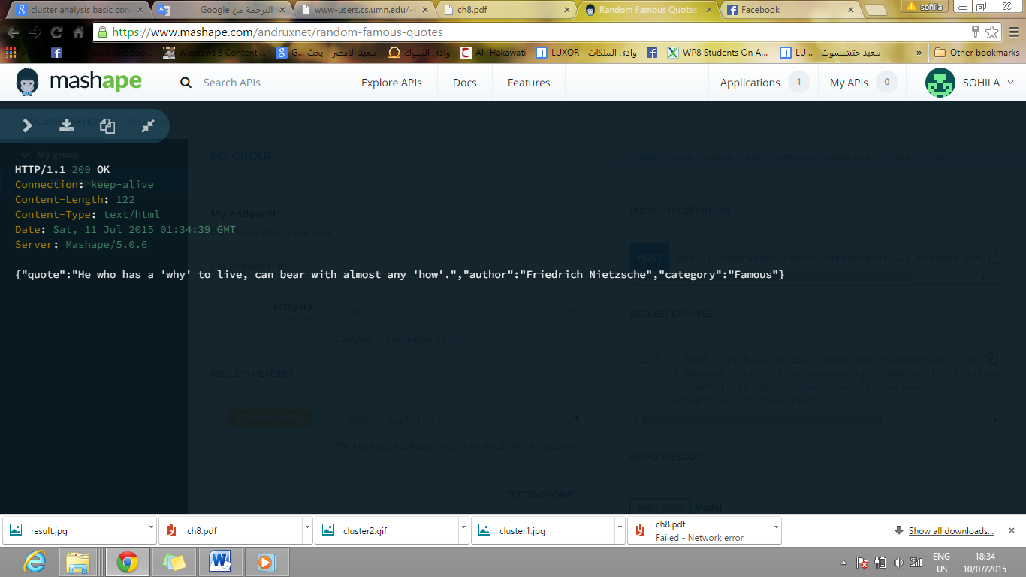 Figure 10.18

Figure 10.19

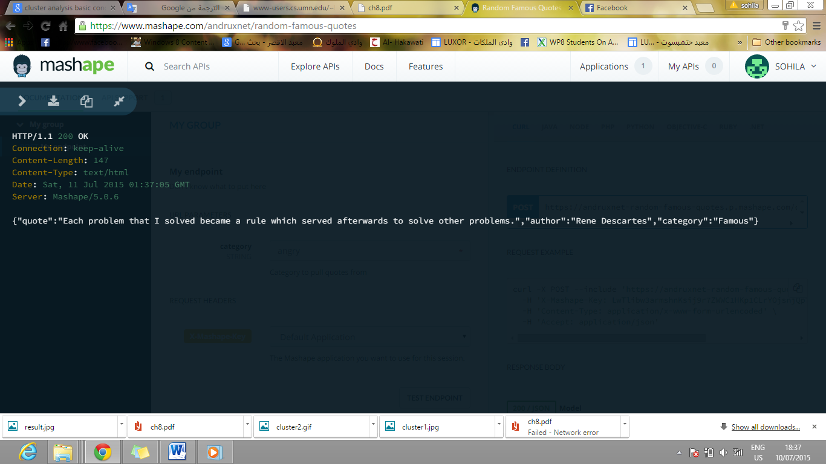Angry mood

Figure 10.20

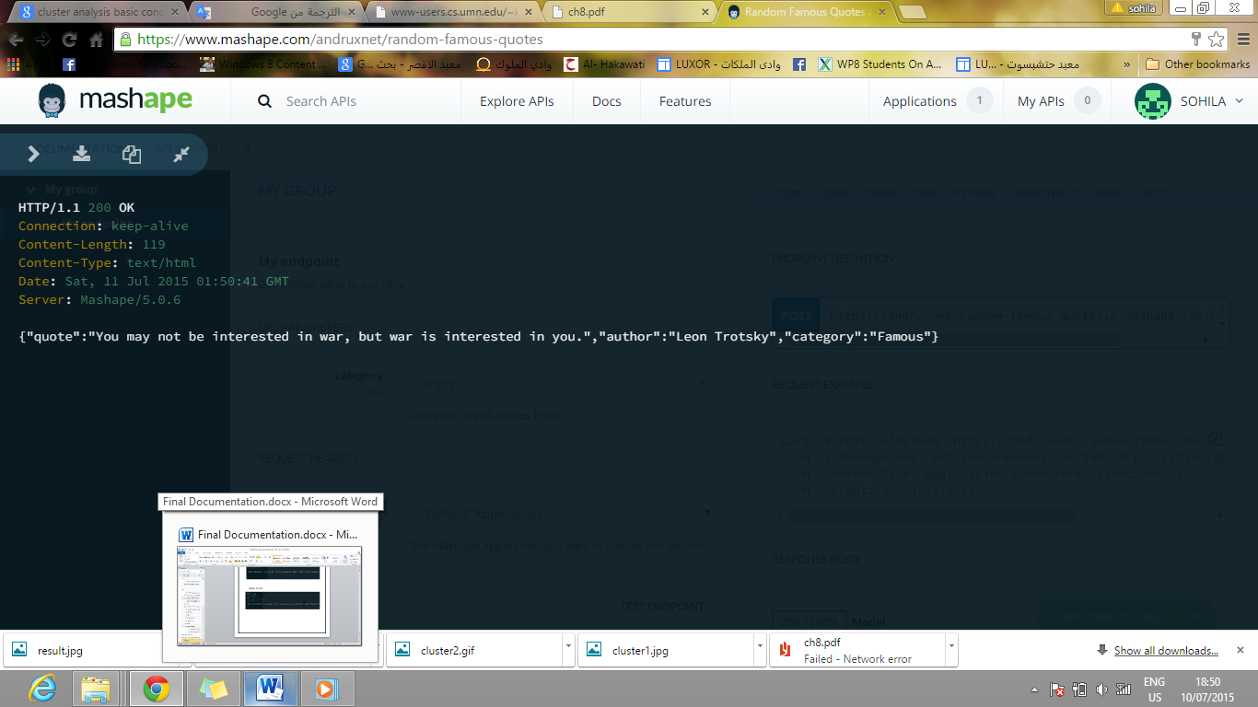 Figure 10.21

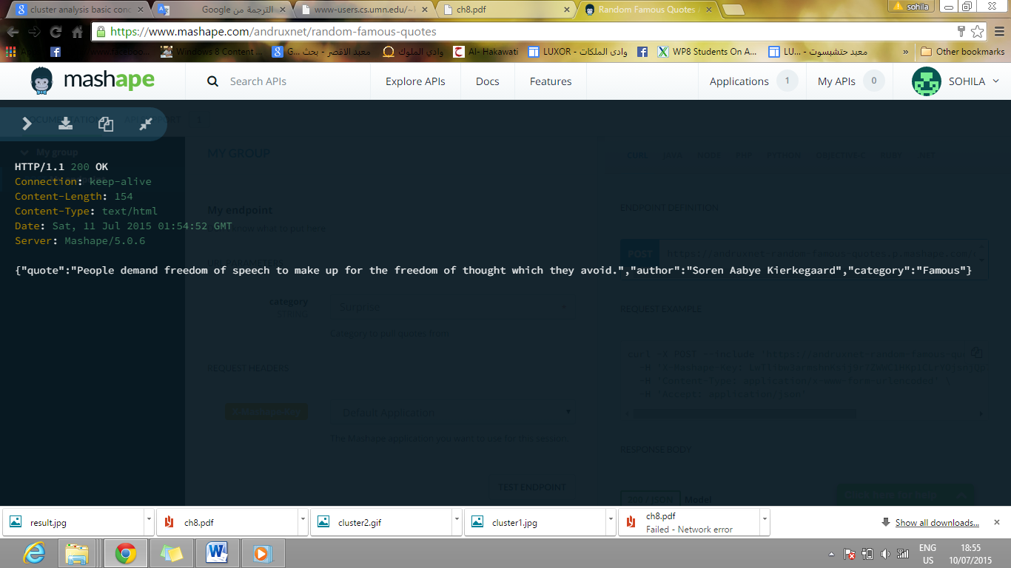Surprise mood

Figure 10.22

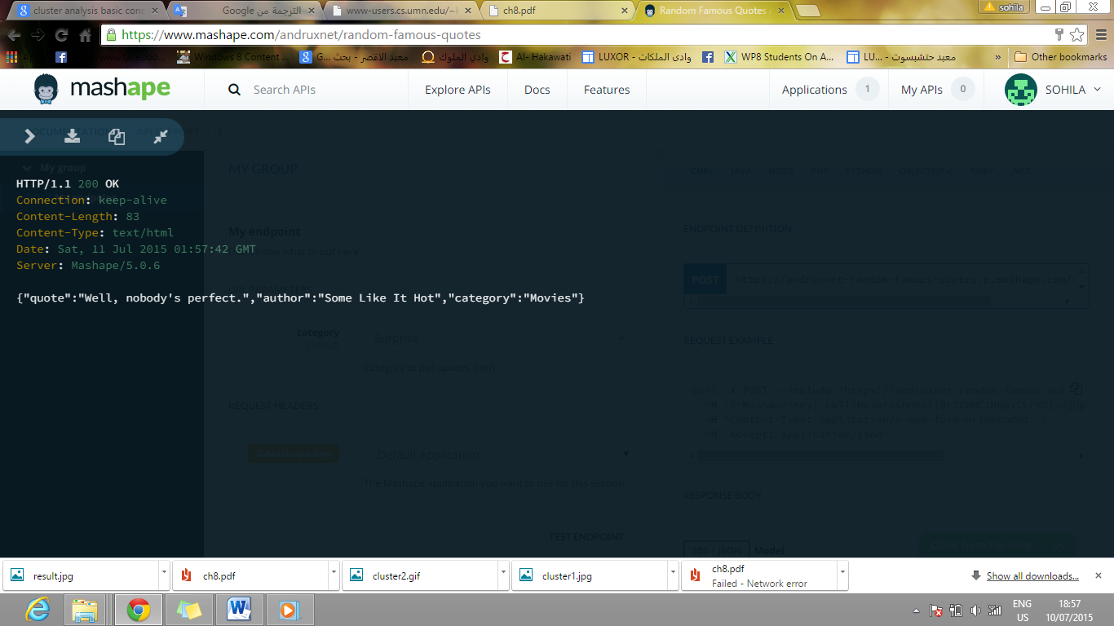 Figure 10.23

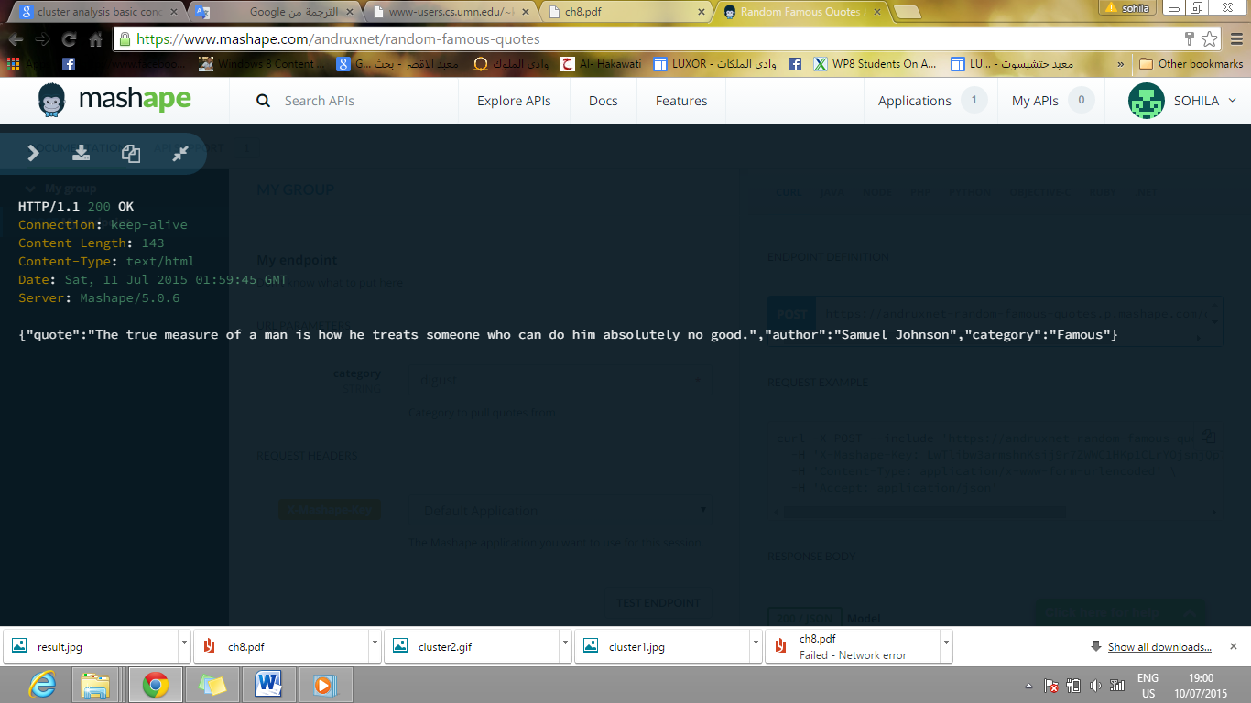Disgust mood

Figure 10.24

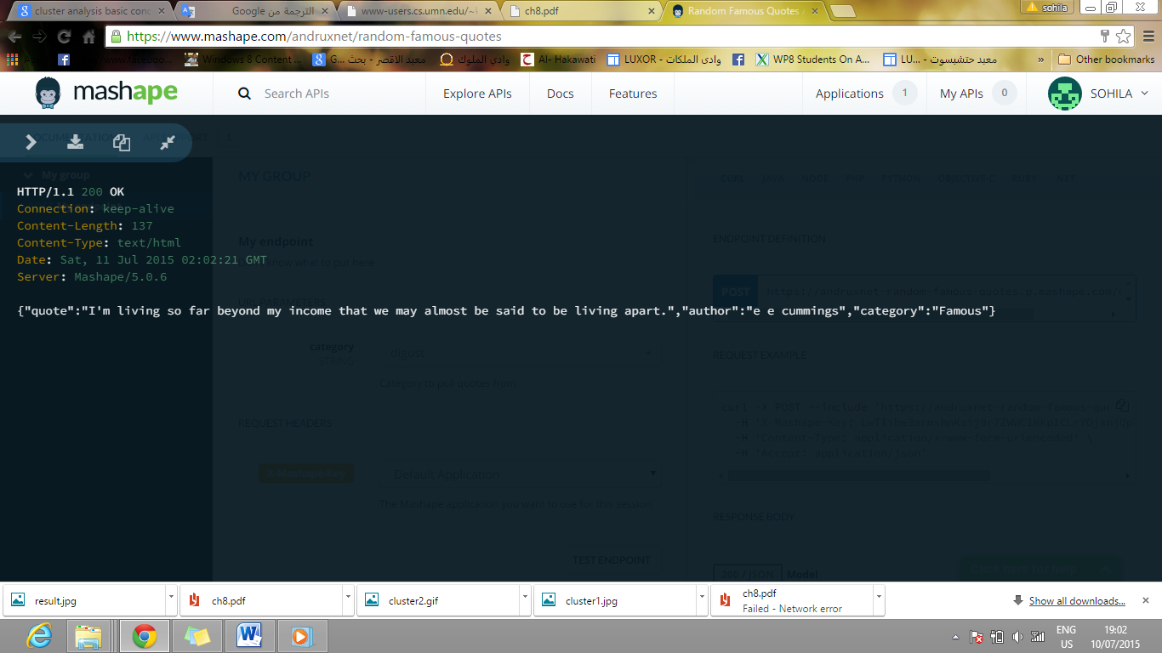

Figure 10.25

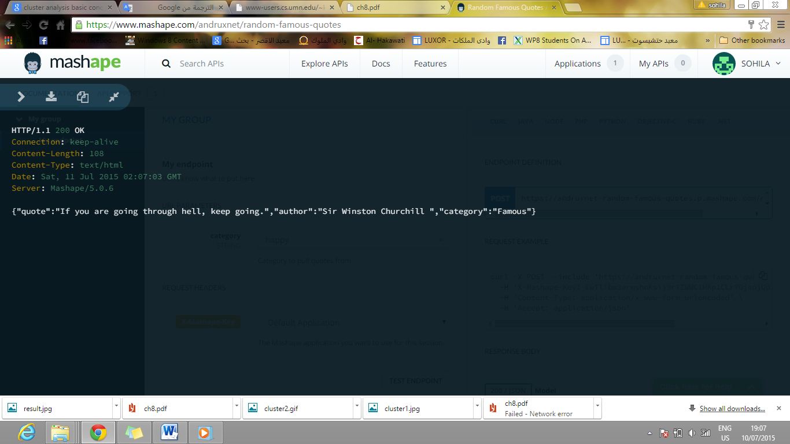Happy mood

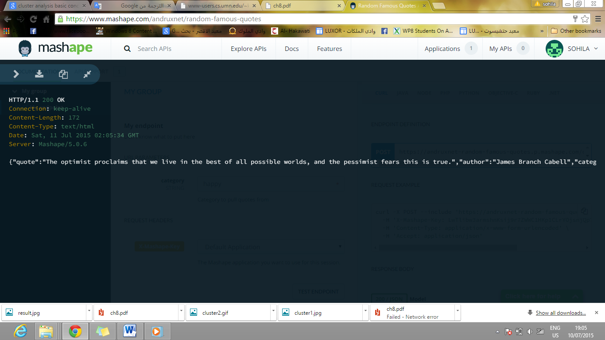Figure 10.26

Figure 10.27

**References**

<https://books.google.com.eg/books?id=00HgQVBRGOcC&pg=PA16&lpg=PA16&dq=goals+of+emotion+detection&source=bl&ots=7NiQkWfxDg&sig=LMNb8HzyfzyUW5TOnhV9xl6WZ0E&hl=en&sa=X&ei=tX-SVcq2G8LlUbjsoOgE&sqi=2&ved=0CGAQ6AEwCA#v=onepage&q=goals%20of%20emotion%20detection&f=false>

<https://www.skybiometry.com/Documentation>

<http://documents.software.dell.com/Statistics/Textbook/Text-Mining>

<http://people.ischool.berkeley.edu/~hearst/text-mining.html>

<http://documents.software.dell.com/Statistics/Textbook/Text-Mining>

<http://stackoverflow.com/questions/10317885/decision-tree-vs-naive-bayes-classifier>

<https://en.wikipedia.org/wiki/Representational_state_transfer>

<http://www.webopedia.com/TERM/A/API.html>

http://maven.apache.org/run-maven/index.html

<http://mahout.apache.org/general/downloads.html>

<https://mahout.apache.org/users/basics/quickstart.html>

<http://notes.variogr.am/post/37675885491/how-music-recommendation-works-and-doesnt-work>

<http://code.tutsplus.com/tutorials/create-a-music-player-on-android-song-playback--mobile-22778>

<http://developer.android.com/guide/topics/media/mediaplayer.html>

<https://developers.soundcloud.com/docs/api/guide#search>

<http://facweb.cs.depaul.edu/mobasher/classes/ect584/Papers/ContentBasedRS.pdf>

<http://recommender-systems.org/content-based-filtering/>